**CSC423: Data Analysis And Regression / CSC 324: Data Analysis & Statistical Software II**

**Summer Assignment-2** | **Total Points: 41pts for CSC 423 and CSC 324**

**Due Date: 07/31/2018 by 11:59 pm**

**Kristen Groom**

**Online student**

***Note: For all questions, immaterial if whether the relevant output is asked to be attached or not, make sure to include it. Also, it is important to include the sign (negative/positive or increase/decrease, and units of measurements e.g. $ or $ 99 million,%, etc.) otherwise points will be deducted.***

**Problem 1 [15pts] – to be answered by everyone**

A national homebuilder builds single-family homes and condominium style townhouses.

The file housesales.txt provides information on the selling price (PRICE), lot cost (COST), type of home (HOME) (SF=single family home or T=condominium style) and region of the country (REGION) (M=Midwest, S=south) for closings during one month.

1. Define the dummy variables for region and home (write them down here), and create them in SAS.

***Answer****:*

*The dummy variables will be the variables representing Region and Type:*

*numregion=1 for Region=’M’ (Midwest) and numregion=0 otherwise,*

*numtype=1 for Type=’SF’ (single family home) and numtype=0 otherwise*

***Code****:*

*\* Get housesales data into dataset;*

*TITLE 'Housesales data with dummy vars';*

*DATA housesales;*

*INFILE 'S:\CSC423\HW2\HouseSales.txt' expandtabs missover firstobs=2;*

*INPUT Region $ Type $ Price Cost;*

*\* Initializing dummy vars for Region and Type;*

*numregion=(Region='M');*

*numtype=(Type='SF');*

*run;*

*PROC PRINT data=housesales;*

*RUN;*

***Output:***

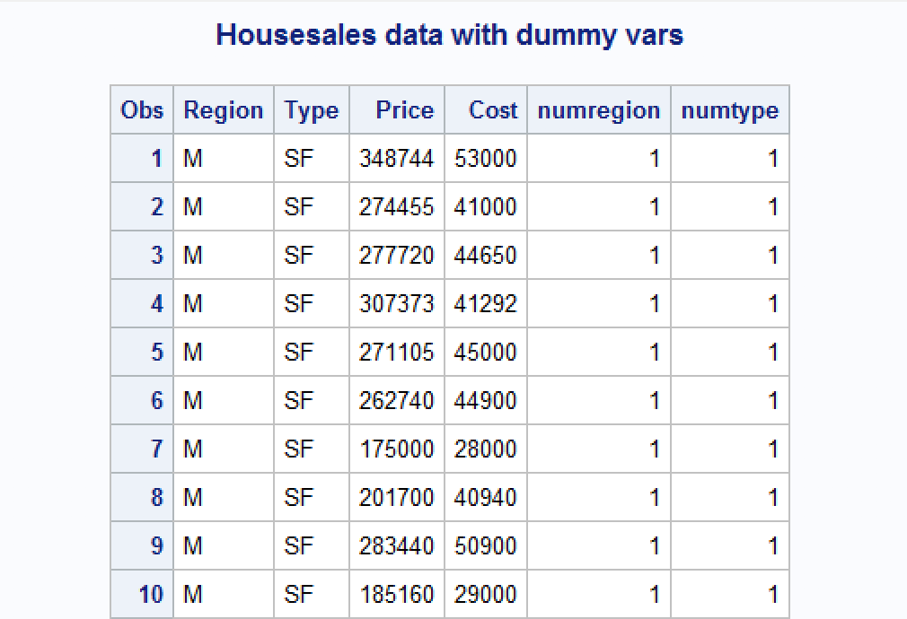

1. Analyze the association between selling price and each individual attribute (cost, home and region) using appropriate statistics and graphs. Discuss your findings. Include the relevant output.

***Answer****:*

*In order to analyze the association between selling price and each individual attribute, we can look at scatterplots or gplots and Pearson Correlation Coefficients.*

***Code****:*

*a)*

*\*Scatterplot matrix for housesales;*

*TITLE 'Scatterplot matrix for housesales data';*

*PROC SGSCATTER;*

*MATRIX Price Cost numregion numtype;*

*RUN;*

*b)*

*\*Correlation Analysis for housesales;*

*TITLE 'Correlation analysis for Housesales data';*

*PROC CORR;*

*VAR Price Cost numregion numtype;*

*RUN;*

***Output:***

1. *Scatterplot matrix*

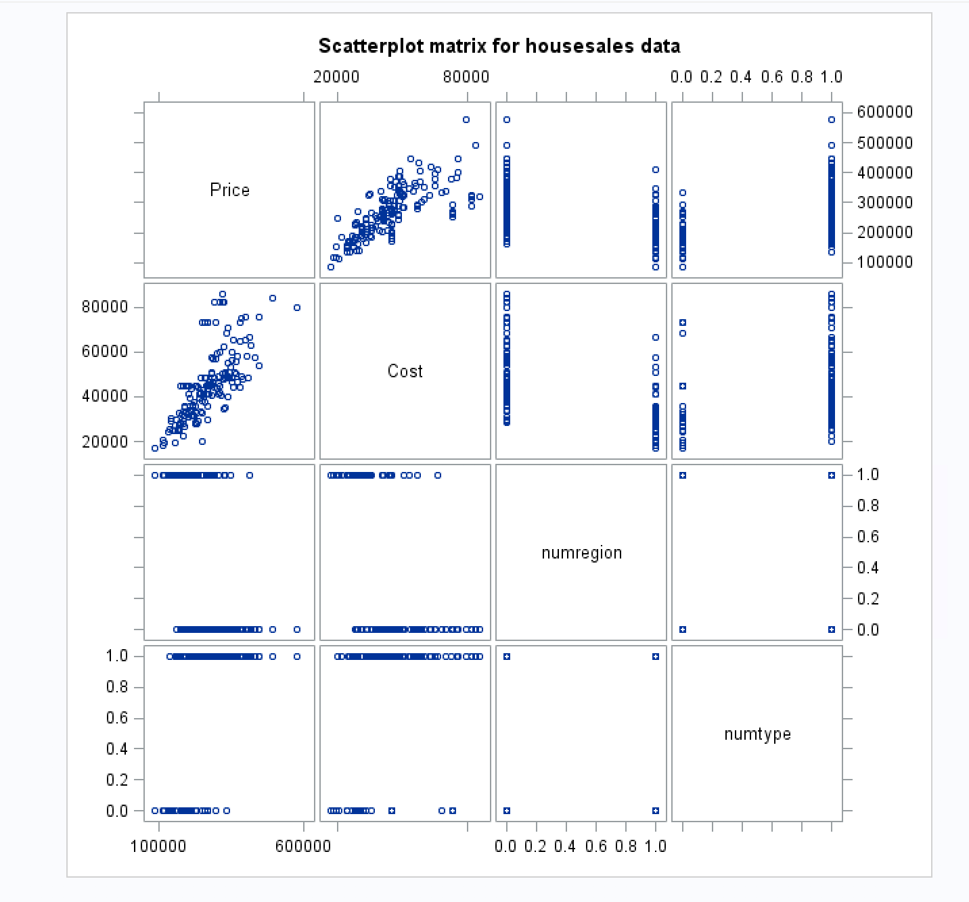

1. *Correlation table:*

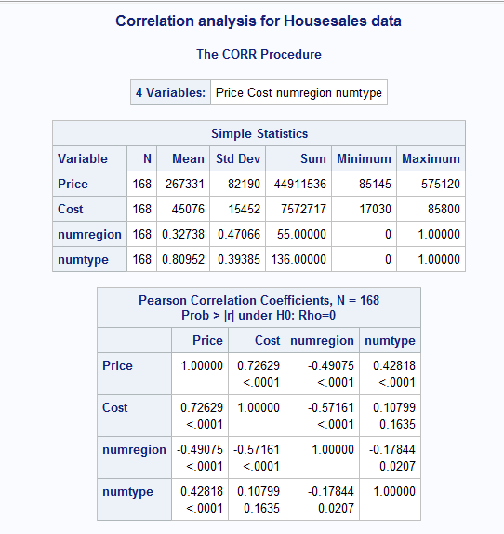

***Findings:***

1. *I can see from the above scatterplot matrix that there is a linear relationship between the home selling price and the lot cost. Upon closer inspection, I notice a slight downward u-curve pattern, however, for our purposes in the following analysis, I will assume linearity because the u-curve may be very slight. I will pay attention to other statistics that suggest goodness of our model fit to see if any problems are evident given the linearity assumption.*
2. *Our Correlation table shows that moderately strong positive association between selling price and lot cost. We can also see a moderately weak negative association between price and home region, and a moderately weak positive association between the type of home and selling price.*
3. Fit an adequate regression model for sales price as a function of lot cost, region of country, and type of home. Remove the terms that are not significant. The final model should only contain variables that are significantly associated with sale price. Write down the model equation. Include the relevant output.

***Answer****:*

*I will start with a PROC REG statement using all the variables, and I will then look at the parameter estimates table and the PR > |t| column to check which variables have a significant effect on our dependent variable of selling price. We will look for alpha values that are <= 0.05 as an indicator of significance.*

***Code****:*

1. *First model:*

*\*Regression Analysis for housesales;*

*TITLE 'Regression Analysis for housesales';*

*PROC REG data=housesales;*

*model Price=Cost numregion numtype;*

*RUN;*

1. *Second model with numregion removed:*

*\*Regression Analysis for housesales with numregion removed;*

*TITLE 'Regression Analysis for housesales - numregions';*

*PROC REG data=housesales;*

*model Price=Cost numtype;*

*RUN;*

***Output:***

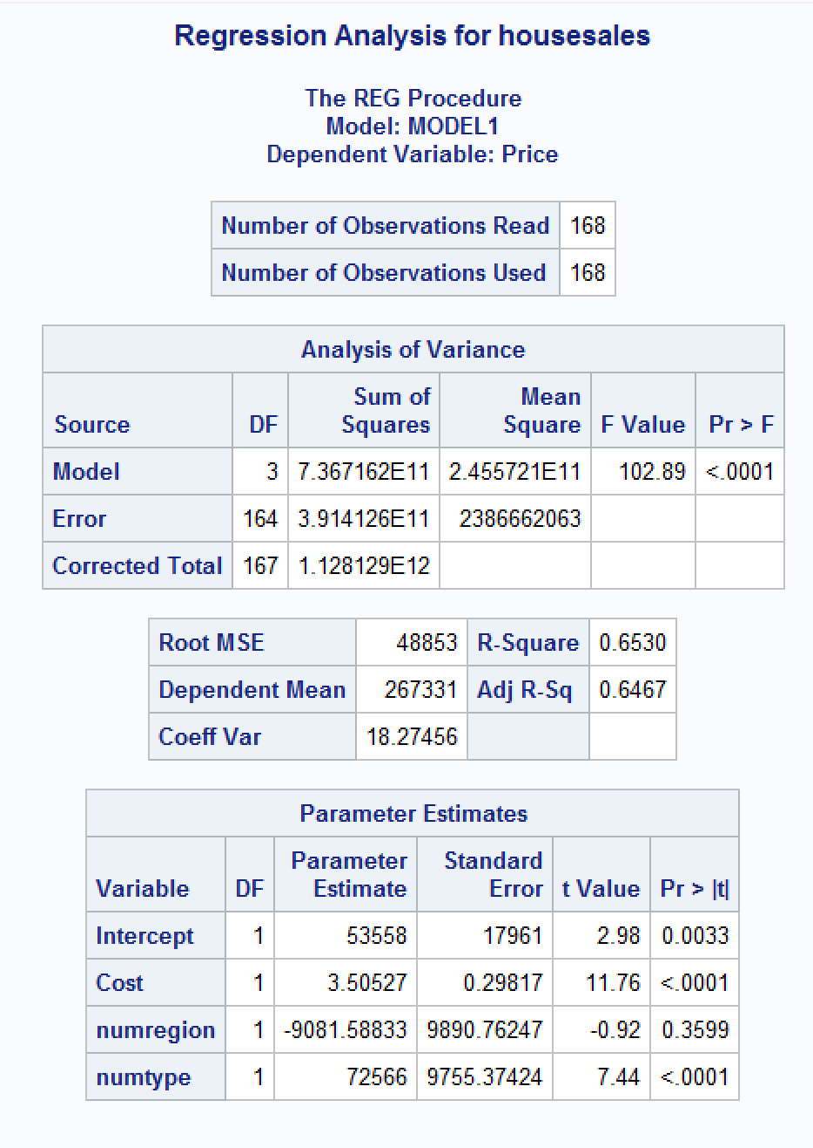

* 1. *Output with numregion var removed:*

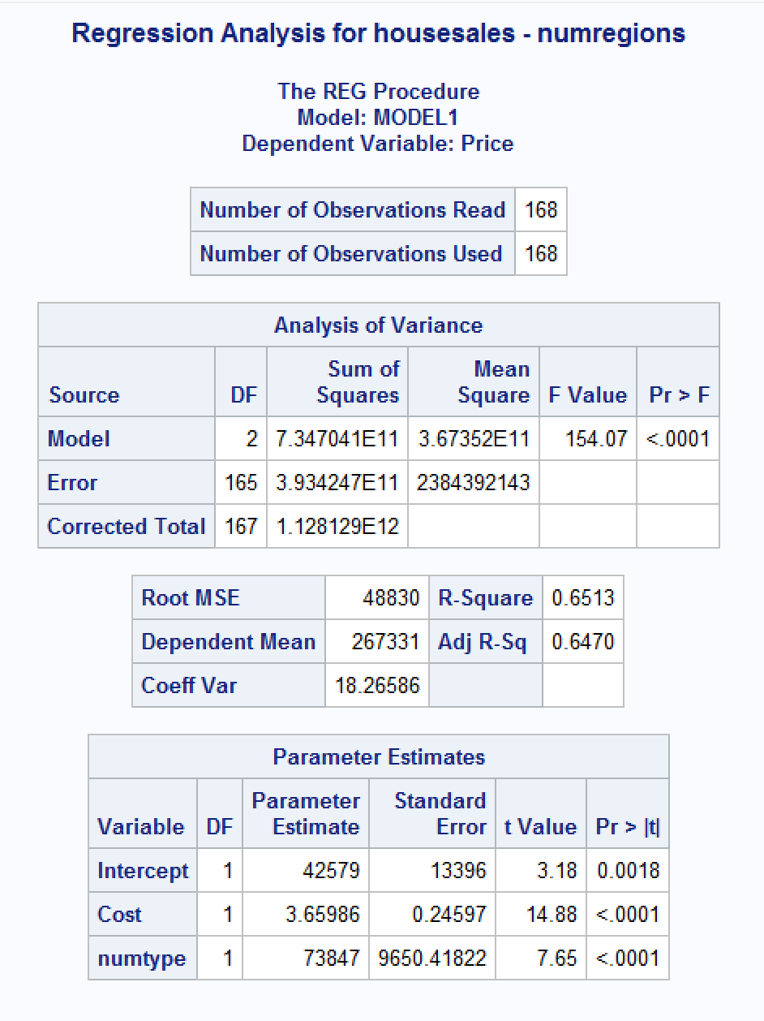

***Findings:***

1. *I can see from the Parameter Estimates table that two of the variable are significant: Cost and numtype, and numregion is not significant with alpha = 0.3599. I noticed that Adj R2 is not very high which suggests that we can do better with our model. I will remove numregion from our model and check Regression Analysis again.*
2. *I now see that for our final model, all of our predictor variables are significant with p-values <.0001. I did not see much of an increase in the Adj R2 which tells me that perhaps our model can continue to be improved because as of now only approximately 65% of the variability of selling price can be explained by this model and as such 35% of the variability of selling price is not accounted for with our model.*
3. Conduct a global F-test for overall model adequacy. Write down the test hypotheses and test statistic and discuss conclusions. Include the relevant output.

***Answer****:*

*Looking at the above Regression analysis in part c) I can find the global F-test. The goodness-of-fit test statistic is F-value which is found by dividing the MSR(mean squared regression) by the MSE(mean square residual) and then finding the p-value.*

*Test hypotheses:*

*Ho = No predictor variables are significant or all beta values are 0*

*HA = At least one of our x or the predictor variables have a significant effect on the dependent variable.*

***Code****:*

*(same code from part c))*

*\*Regression Analysis for housesales with numregion removed;*

*TITLE 'Regression Analysis for housesales - numregions';*

*PROC REG data=housesales;*

*model Price=Cost numtype;*

*RUN;*

***Output:***

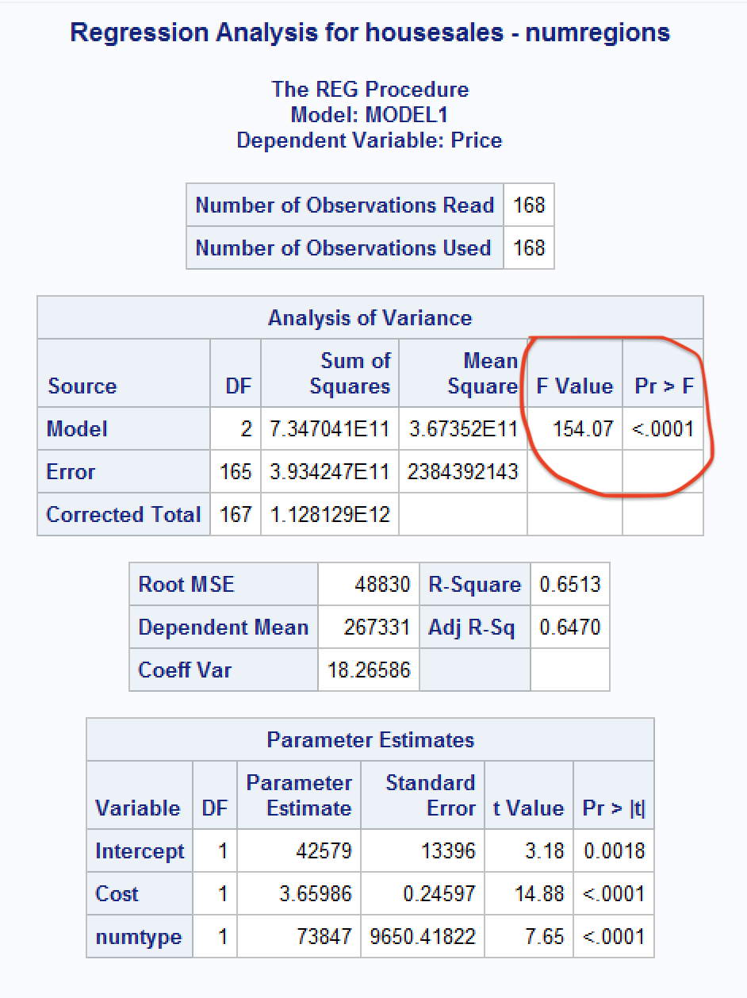

***Findings:***

*We can see from our output that the F-value is high at 154.07 and that our p-value is <0001 which is less than alpha = 0.05. This tells us that at least one of our predictor variables is significant and therefore we have sufficient evidence to reject the null hypothesis.*

1. Analyze model residuals to check if assumptions on data are satisfied. Discuss your findings. Include the relevant output.

***Answer****:*

*I will perform Regression Analysis with model residuals and standardized residuals to test for*

*1) Linearity 2) Constant variance 3) Independence 4)Normality*

***Code****:*

*\*regression model to predict selling price;*

*TITLE 'Regression Analysis with model residuals';*

*PROC REG data=housesales;*

*MODEL Price=Cost numtype;*

*\*residual plots;*

*PLOT student.*predicted.;*

*PLOT student.*(Cost numtype);*

*PLOT npp.*student.;*

*run;*

***Output:***

*(I’m adding the scatterplot matrix from part b) above)*

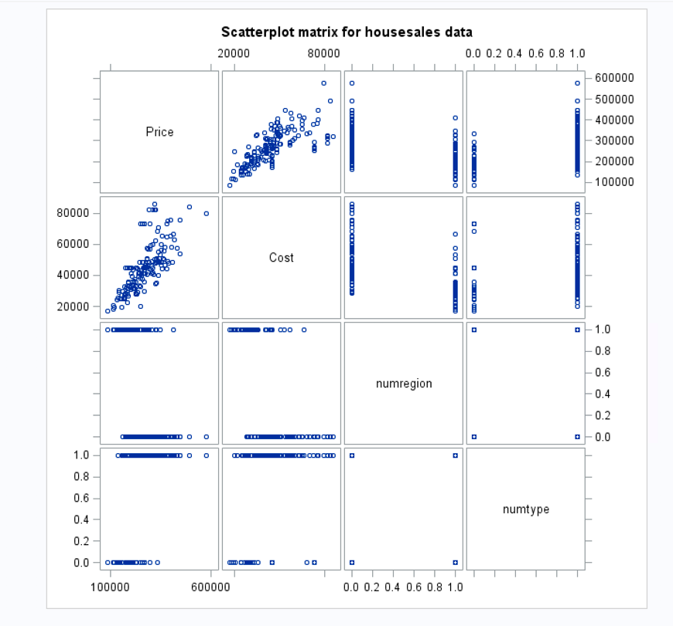

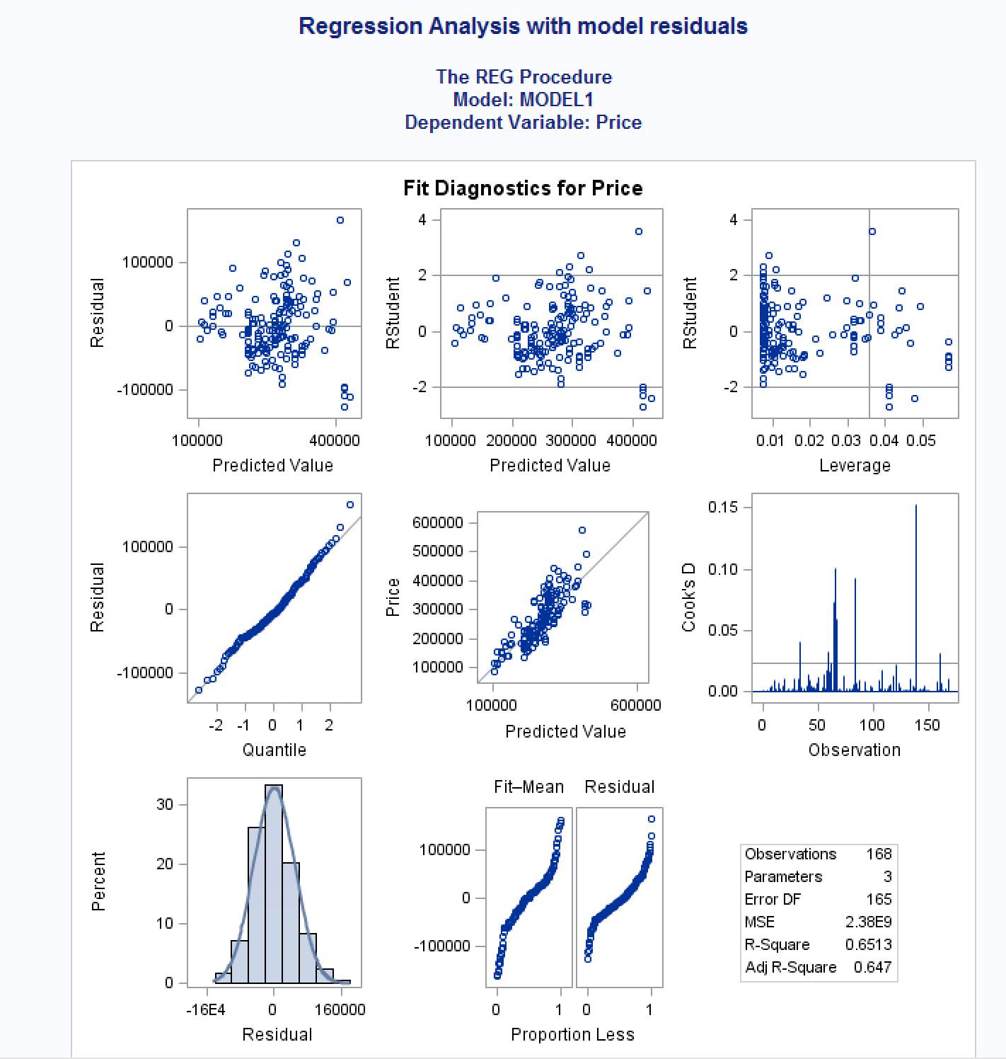

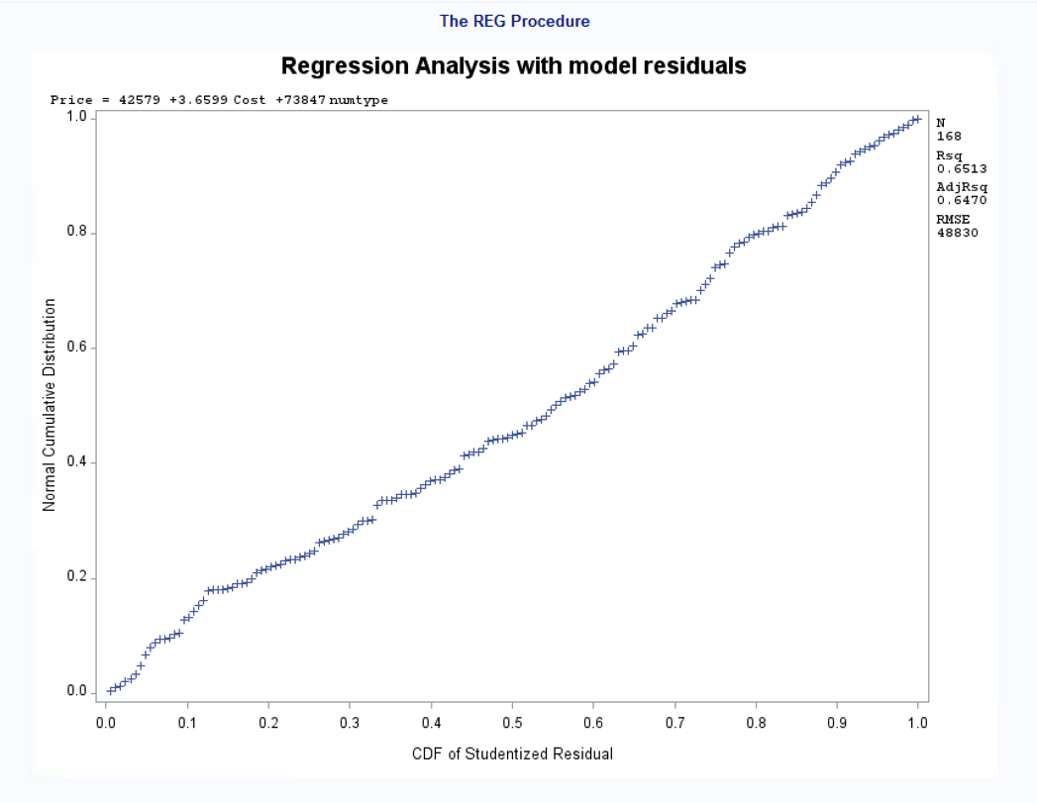

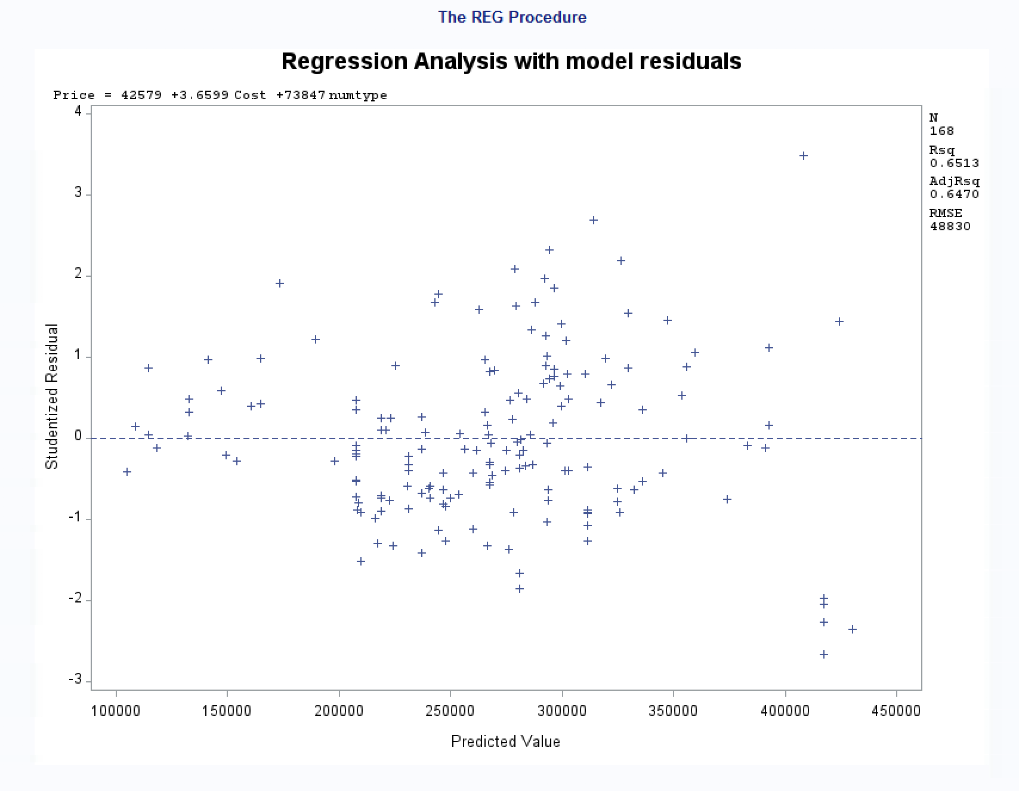

***Findings:***

*I can see from the scatterplot matrix above that our model does not violate linearity. The association between Price and Cost appears to be linear to me although I see the possibility of some outliers that could be influencing our model accuracy. I see from the Fit Diagnostics for Price table that we are not violating Constant Variance or Independence because I can see the data points scattered equally around the 0 line in the standard residuals plot and the studentized residuals plot, although, I can see the possibility of at least one outlier which could be affecting our model’s goodness of fit. Also, looking at the normality plot, it appears that the points lie close to the line at a 45 degree angle, which suggests that our residuals are assumed to be approximately normal.*

1. Discuss what the regression model indicates for the relationship between price and home type (i.e. interpret the coefficient values).

***Answer****:*

*(Adding Regression Analysis output from part c) above)*

**

*The final fitted model is: Price = 42579 + 3.65986(Cost) + 73847(numtype)*

*where numtype=1 when Type=’SF’ (single family home), otherwise 0*

*We can expect the selling price to increase by approximately $3.65986 (I’m guessing per square foot or it could be in thousands? This isn’t clear in our data) when our lot price increases by one unit, again, this could per sq. foot or thousands of dollars, but this is not specified.*

*As for the type of home, we can expect our selling price to increase by $73,847 when we move from a condominium style home to a single family home.*

1. Use the regression analysis to determine whether mean sale prices are different for the two regions? Explain.

*Answer:*

*In our regression analysis, we found that the dummy variable numregion which represents the two different regions in our data, is not significant. This means that house sales within these two regions do not have a significant effect on the median selling price of homes, therefore it was removed it from the final model. It can be said that the regions represented do not affect the selling price of homes in our dataset.*

1. Copy and paste your FULL SAS code into the word document along with your answers.

*Answer: See code and output above.*

**PROBLEM 2 [16 pts] – to be answered by everyone**

The file bankingfull.txt attached to this assignment contains the full dataset. It provides data acquired from banking and census records for different zip codes in the bank’s current market. Such information can be useful in targeting advertising for new customers or for choosing locations for branch offices. The data show

* median age of the population (AGE)
* median years of education (EDUCATION)
* median income (INCOME) in $
* median home value (HOMEVAL) in $
* median household wealth (WEALTH) in $
* average bank balance (BALANCE) in $

The goal of this exercise is to define a regression model to predict the average bank balance as a function of the other variables.

1. Create scatterplots to visualize the associations between bank balance and the other five variables. Include the relevant output. Discuss the patterns displayed by the scatterplot. Also, explain if the associations appear to be linear? (you can create either scatterplots or a matrix plot)

***Answer****:*

***Code****:*

*\* Get banking data into dataset;*

*TITLE 'Bankingfull data in dataset using infile';*

*DATA bankingfull;*

*INFILE 'S:\CSC423\HW2\Bankingfull.txt' expandtabs missover firstobs=2;*

*INPUT Age Education Income HomeVal Wealth Balance;*

*run;*

*PROC PRINT data=bankingfull;*

*RUN;*

*\*Scatter plots for bankingfull;*

*TITLE 'Scatterplot matrix for bankingfull data';*

*PROC SGSCATTER;*

*MATRIX Age Education Income HomeVal Wealth Balance;*

*RUN;*

***Output:***

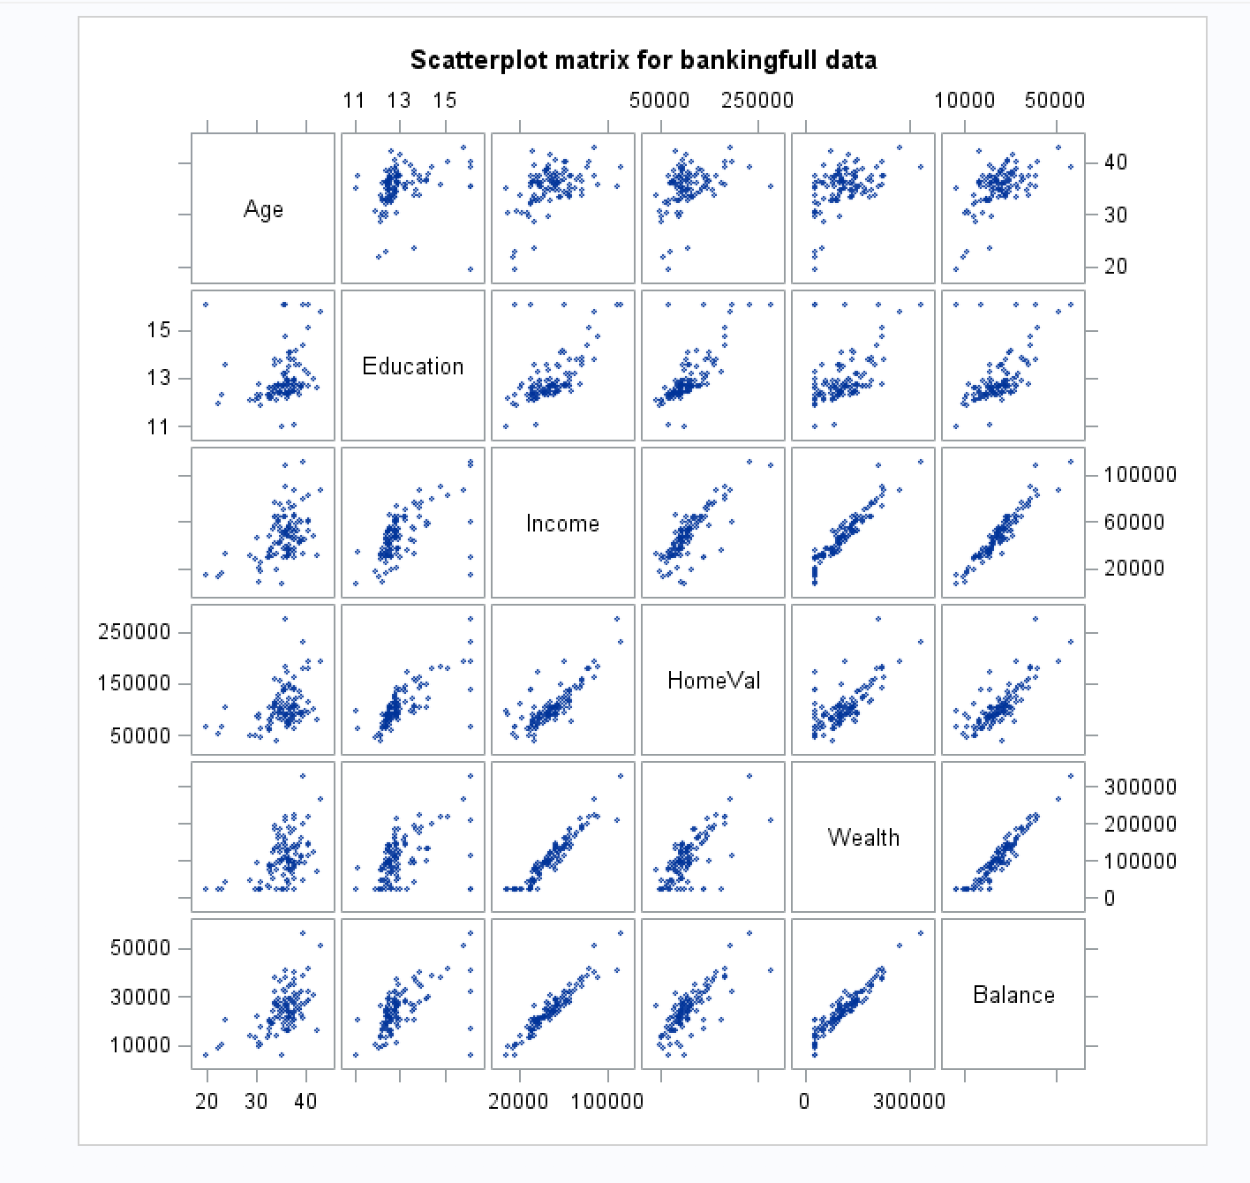

***Findings:***

*The scatterplots that look linear to me and thus suggest strong associations between Balance and the other variables are: Wealth, HomeVal, and Income. The plot showing the correlation between Balance and Education looks like it shows outliers and may have some curve to it. The Age and Balance plot looks curved to me, again this plot has evidence of possible outliers and influential points that may be affecting the linearity of the plot so I will look for multicollinearity, outliers, influential points, and possibly perform transformations of the variables as needed*

1. Compute correlation values of bank balance vs the other variables. Include the relevant output. Interpret the correlation values, and discuss which variables appear to be strongly associated.

***Answer****:*

***Code****:*

*\*Correlation Analysis for bankingfull;*

*TITLE 'Correlation analysis for Bankingfull data';*

*PROC CORR;*

*VAR Age Education Income HomeVal Wealth Balance;*

*RUN;*

***Output:***

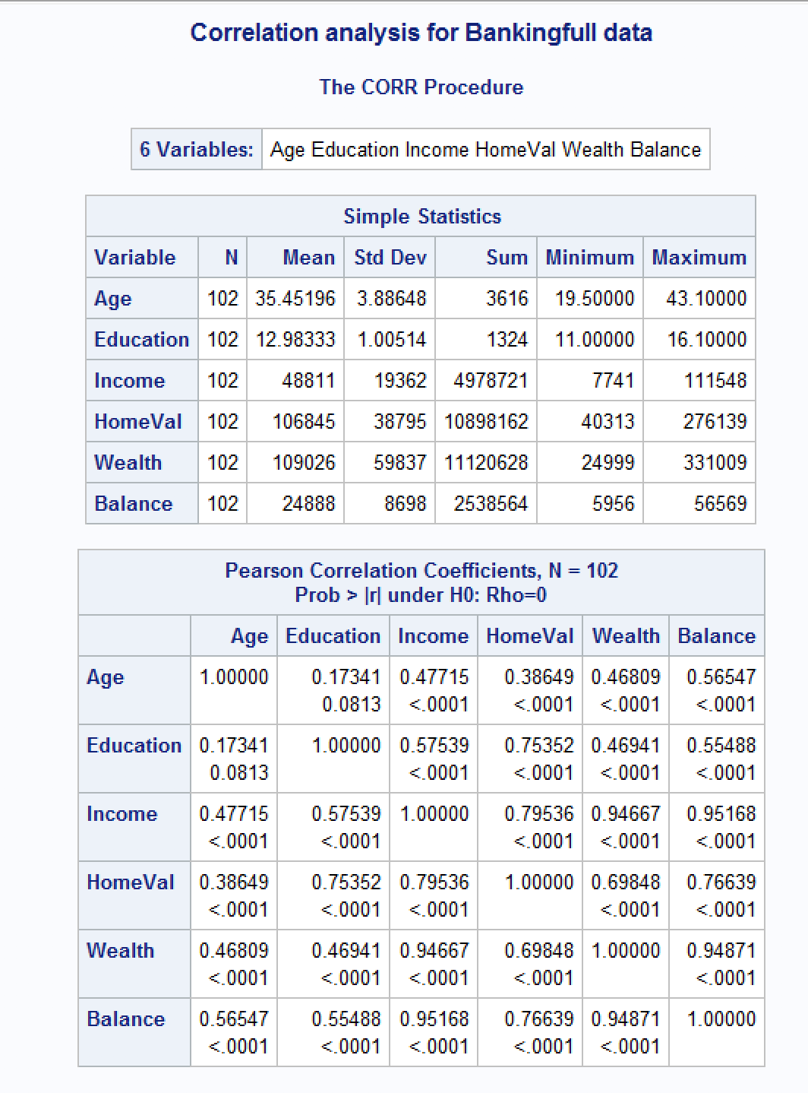

***Findings:***

*From the Correlation Analysis, I can see that my assumptions of linear association were confirmed for the predictor variables Income, Wealth, and HomeVal which all three have positive associations with Balance. Income and Wealth are very strong with both having r-values of approximately 0.95. HomeVal is still a moderately strong association at approximately 0.77. Age and Education have positive associations as well but not as strong as the other variables.*

*I am also seeing some collinearity between Wealth and Income with r = 0.94, which I would assume to be true given that these two attributes are very similar, if not almost identical.*

1. Fit a regression model of balance vs the other five variables (model M1). Compute the VIF statistics for each x-variable and analyze whether there is a problem of multicollinearity and take appropriate action. Include the relevant output. Discuss your answer.

***Answer****:*

***Code****:*

*\* Regression Model for bankingfull with VIF;*

*TITLE 'Regression Model for Bankingfull with VIF';*

*PROC REG data=bankingfull;*

*model Balance=Age Education Income HomeVal Wealth /vif;*

*run;*

***Output:***

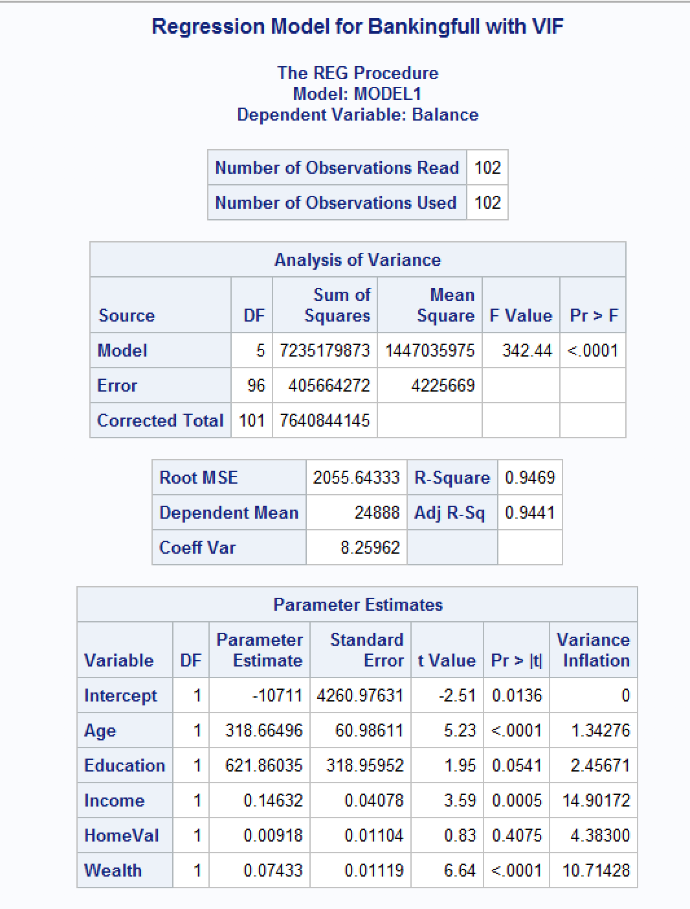

***Findings:***

*In the Parameter Estimates table and in the Variance Inflation column I see that Wealth = 10.71428 and Income = 14.90172, so both have high VIF, that is VIF >= 10, which tells us that there is a problem with multicollinearity.*

1. Apply your knowledge of regression analysis to define a better model M2. Include the SAS output for both models and answer the following questions :
   1. Analyze the adj-R2 values for both models M1 and M2. Which model has the largest adj-R2 value?

***Answer****:*

***M1:***

*\* Regression Model for bankingfull with VIF;*

*TITLE 'Regression Model for Bankingfull with VIF';*

*PROC REG data=bankingfull;*

*model Balance=Age Education Income HomeVal Wealth /vif;*

*run;*



***M2:***

*I tried first dropping Income from the dataset, and then I tried only dropping Wealth to see how dropping one or the other would affect the model:*

*\* Dropping Variable Income from bankingfull;*

*data bankingfull_new;*

*set bankingfull;*

*drop Income;*

*run;*

*TITLE 'Bankingfull without Income';*

*proc print data=bankingfull_new;*

*run;*

*\* Dropping Variable Wealth from bankingfull;*

*data bankingfull_new;*

*set bankingfull;*

*drop Wealth;*

*run;*

*TITLE 'Bankingfull without Wealth';*

*proc print data=bankingfull_new;*

*run;*

***Without Income:***

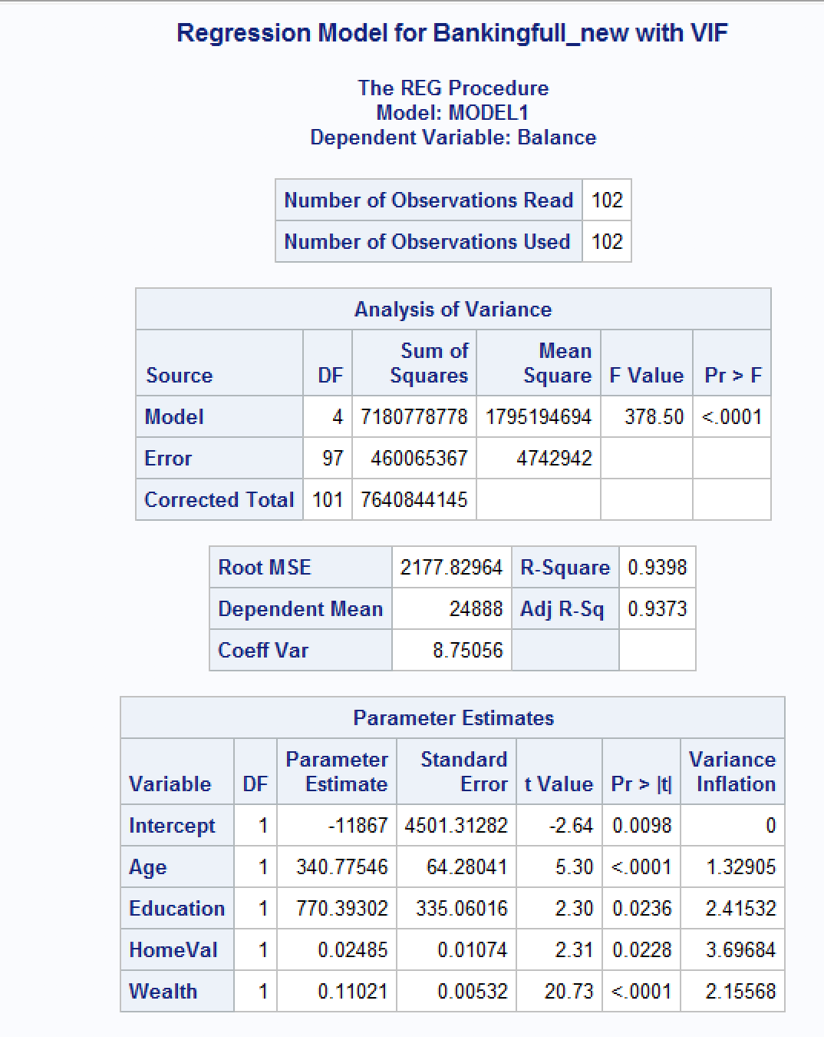

***Without Wealth:***

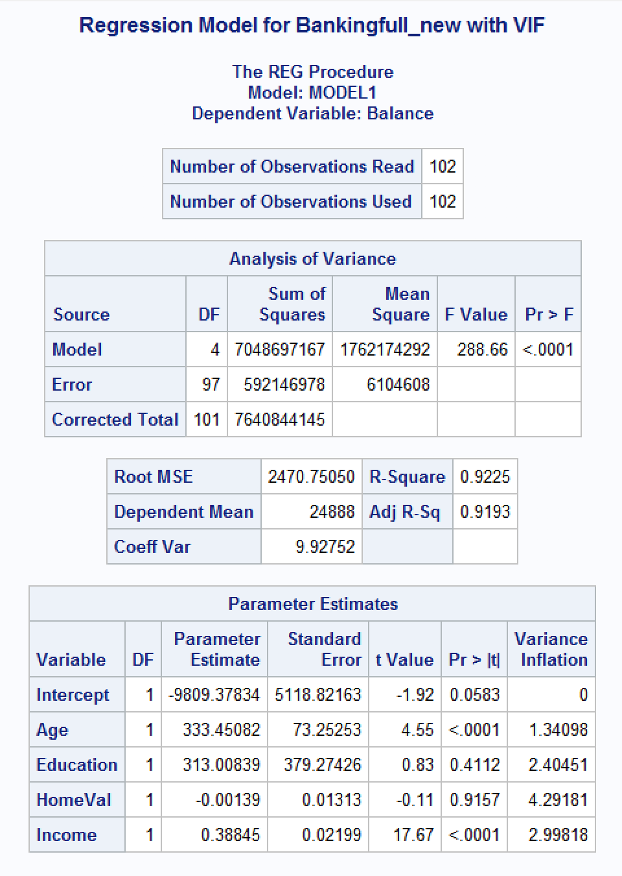

***Findings:***

*I see that the regression model that includes both Income and Wealth has the highest Adj R2 at 0.9441. The model without Income Adj R2 = 0.9373, and then modeling without Wealth gives me Adj R2 = 0.9193. Over 90% of the variability is accounted for with all three models although I would consider removing Income because the model with it removed has an Adj R2 that is higher than if I chose to remove Wealth. It is approximately 0.94, which is also what our original Adj R2 is at. I also see that there is no more VIF >= 10 for any of the variables after the removal of Income or Wealth. I see that the significance of the Education and HomeVal variables are both improved if I remove Income vs if I remove Wealth. If I remove Income, then all the variables are significant. If I remove Wealth, then two of the variable show alpha > 0.05 which would suggest that they are insignificant and I should remove one at a time. I will consider this as I continue my analysis to see which model of the three improves the most.*

* 1. Create residual plots (standardized residuals vs predicted; standardized residuals vs x-variables; and normal plot of residuals). Analyze the residual plots to check if the regression model assumptions are met by the data. Include the relevant output and discuss your analysis.

***Answer****:*

***M1:***

*\*regression model for bankingfull with model residuals;*

*TITLE 'Regression Analysis for bankingfull with model residuals';*

*PROC REG data=bankingfull;*

*MODEL Balance=Age Education HomeVal Income Wealth;*

*\*residual plots;*

*PLOT student.*predicted.;*

*PLOT student.*(Age Education HomeVal Income Wealth);*

*PLOT npp.*student.;*

*run;*

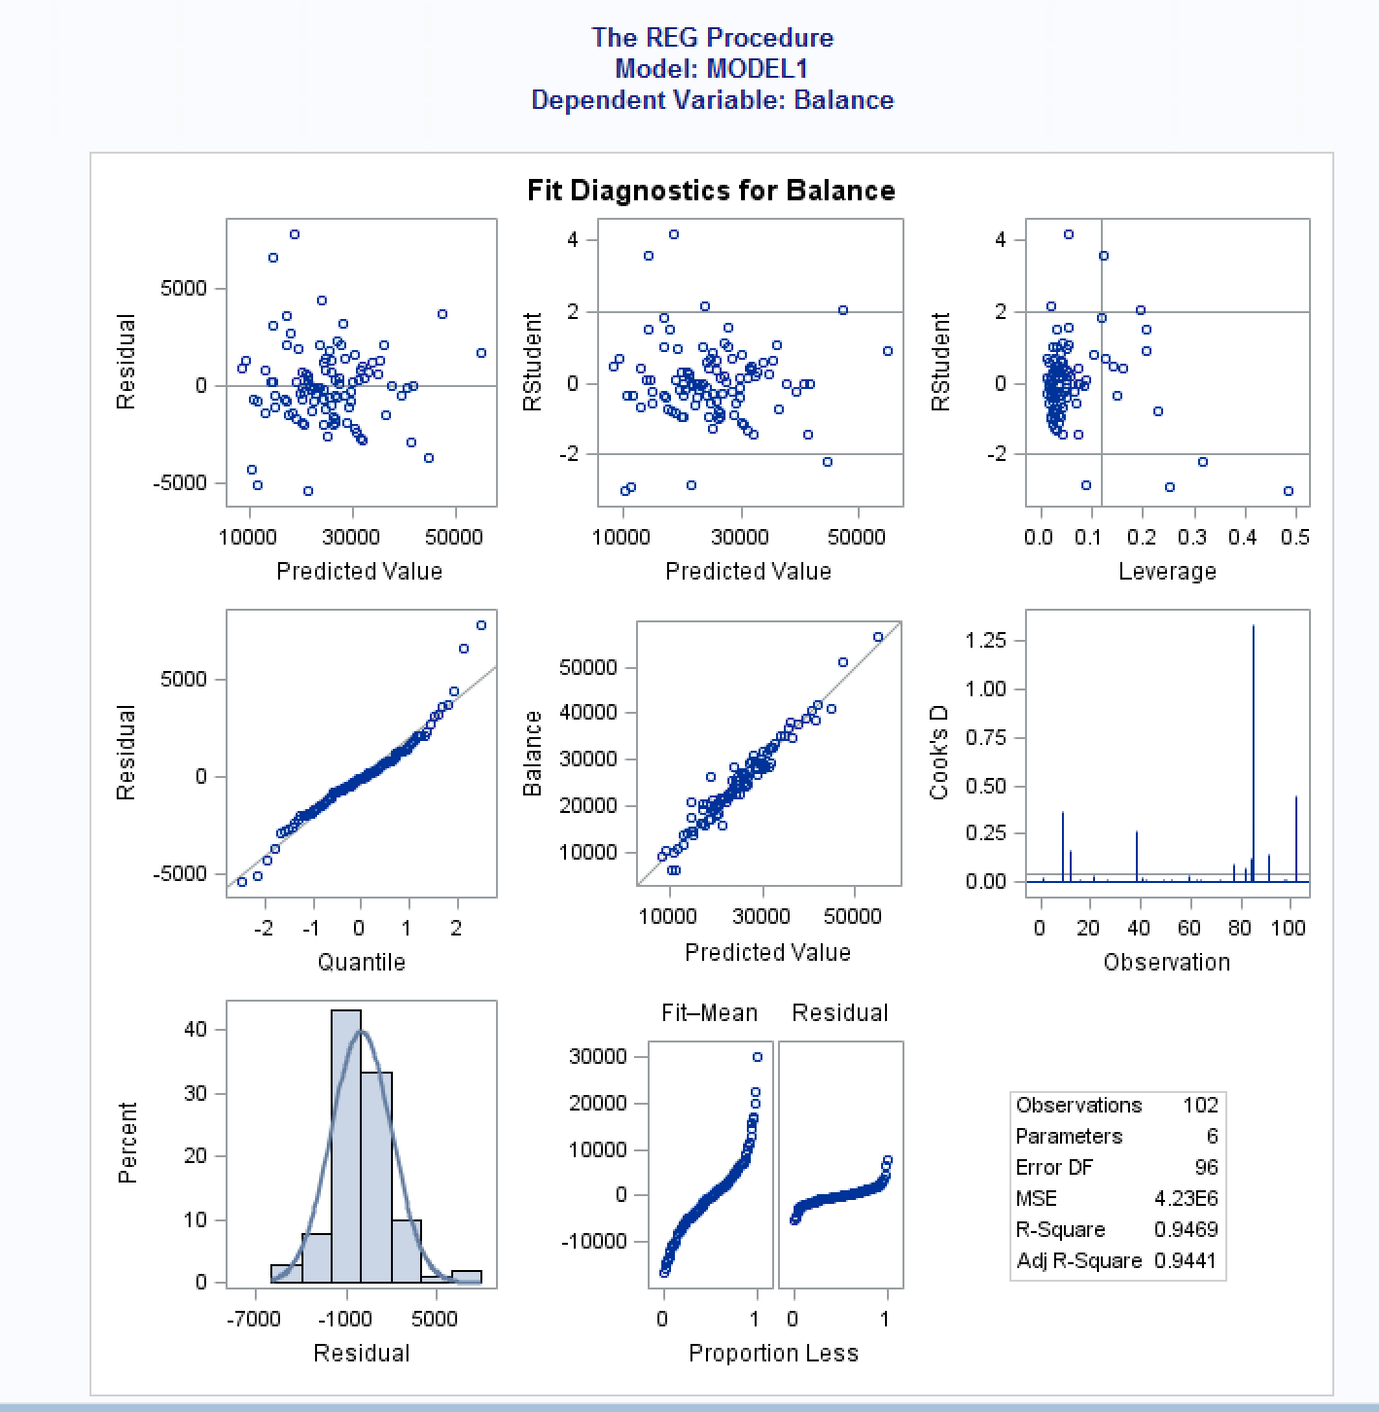

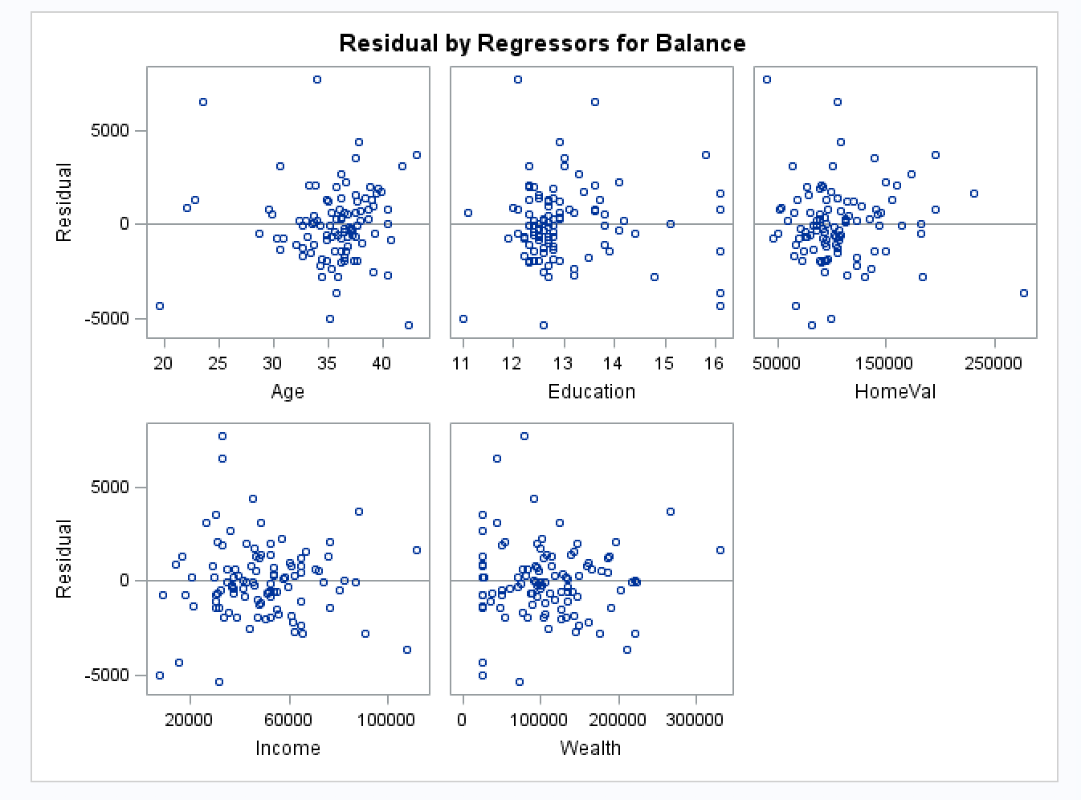

***M2 with Income removed:***

*\*regression model for bankinfull_new without Income with model residuals;*

*TITLE 'Regression Analysis for bankingfull_new without Income with model residuals';*

*PROC REG data=bankingfull_new;*

*MODEL Balance=Age Education HomeVal Wealth;*

*\*residual plots;*

*PLOT student.*predicted.;*

*PLOT student.*(Age Education HomeVal Wealth);*

*PLOT npp.*student.;*

*run;*

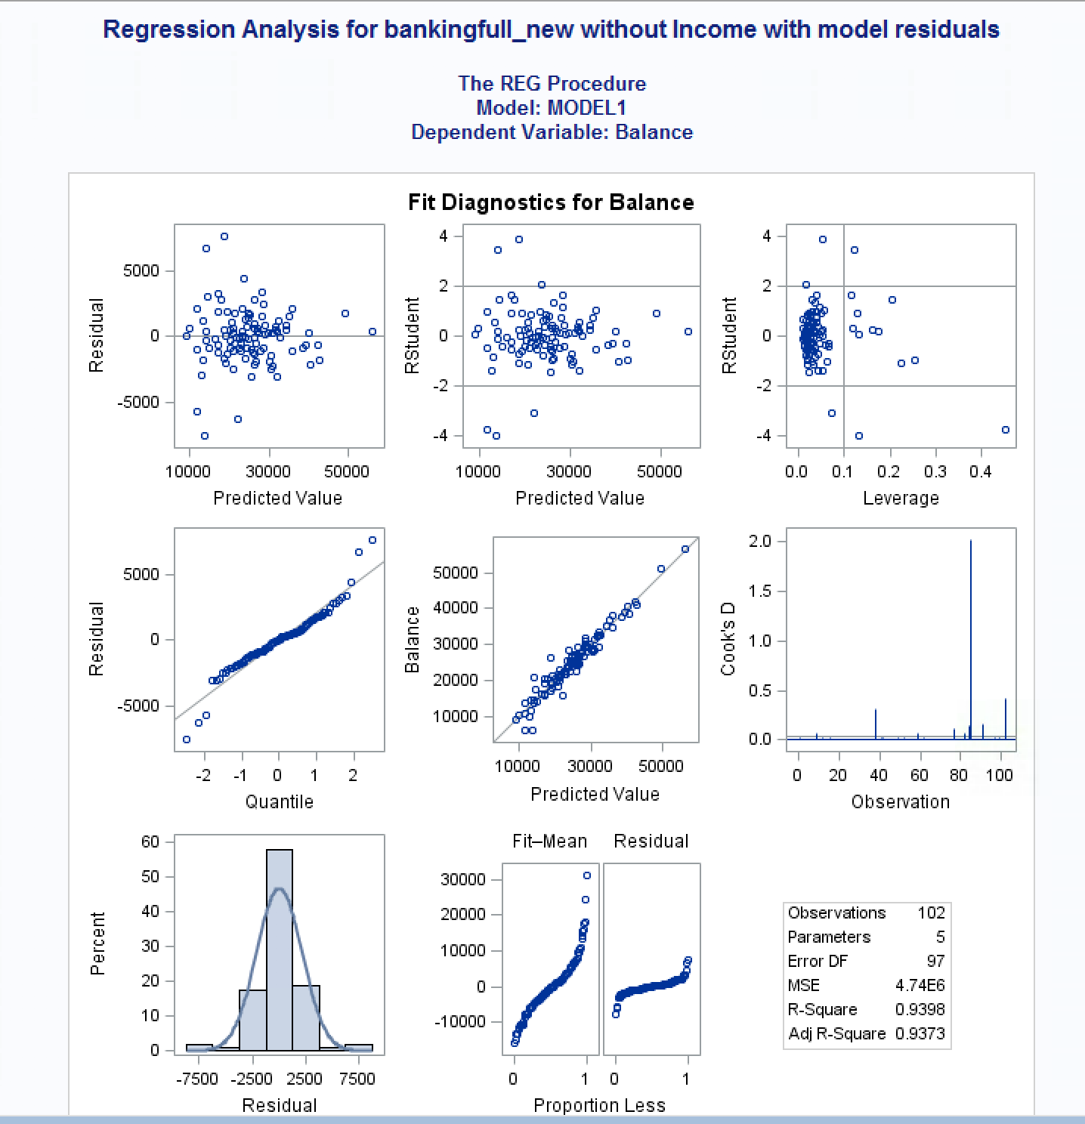

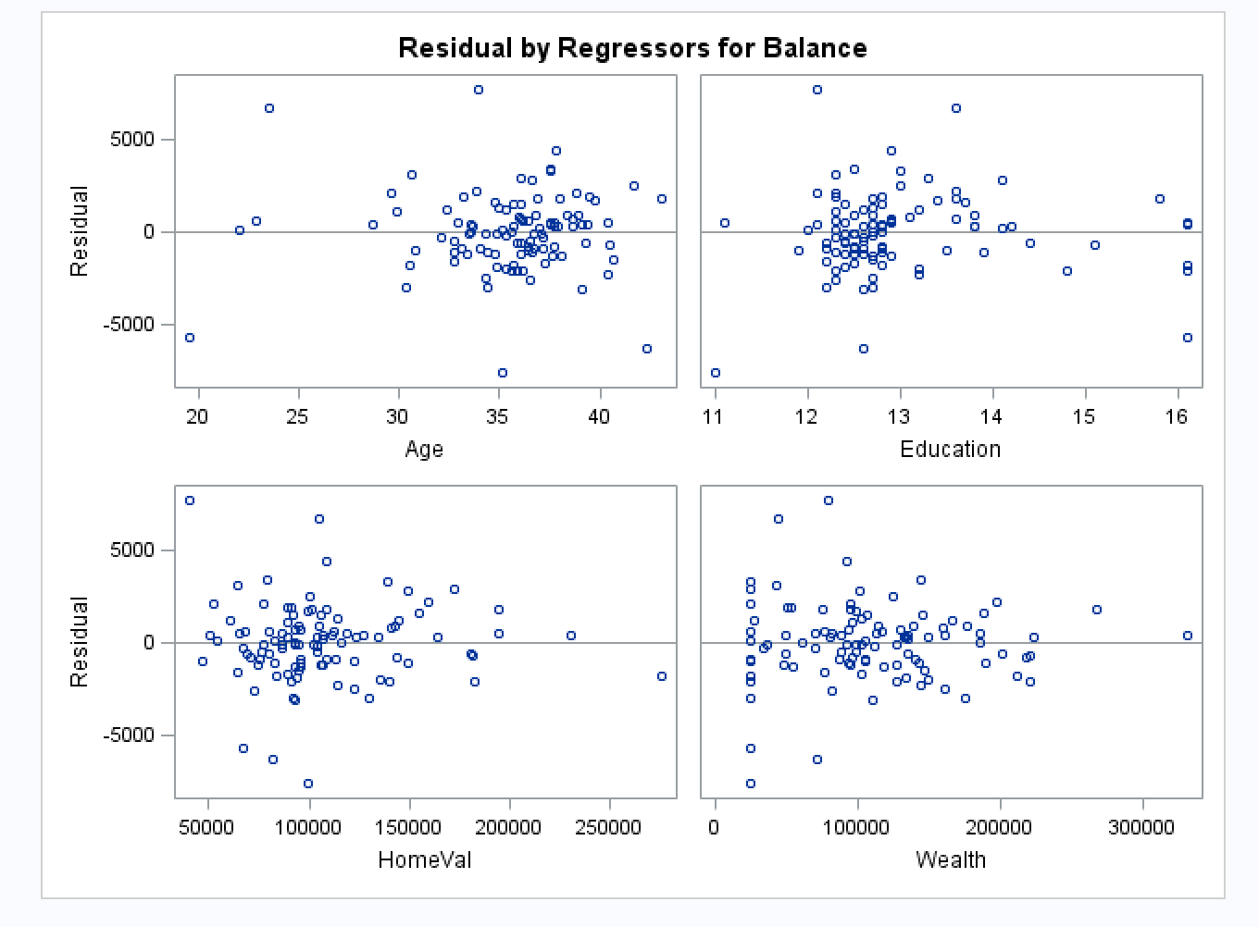

***M2 with Wealth removed:***

*\*regression model for bankinfull_new without Wealth with model residuals;*

*TITLE 'Regression Analysis for bankingfull_new without Wealth with model residuals';*

*PROC REG data=bankingfull_new;*

*MODEL Balance=Age Education HomeVal Income;*

*\*residual plots;*

*PLOT student.*predicted.;*

*PLOT student.*(Age Education HomeVal Income);*

*PLOT npp.*student.;*

*run;*

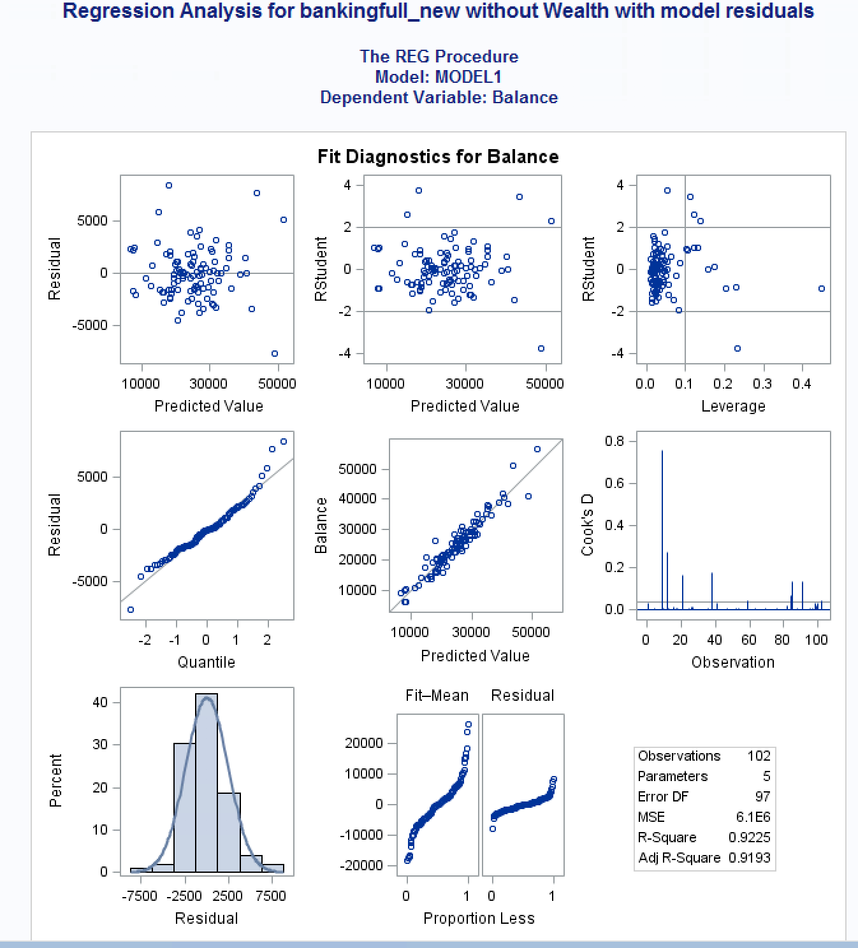

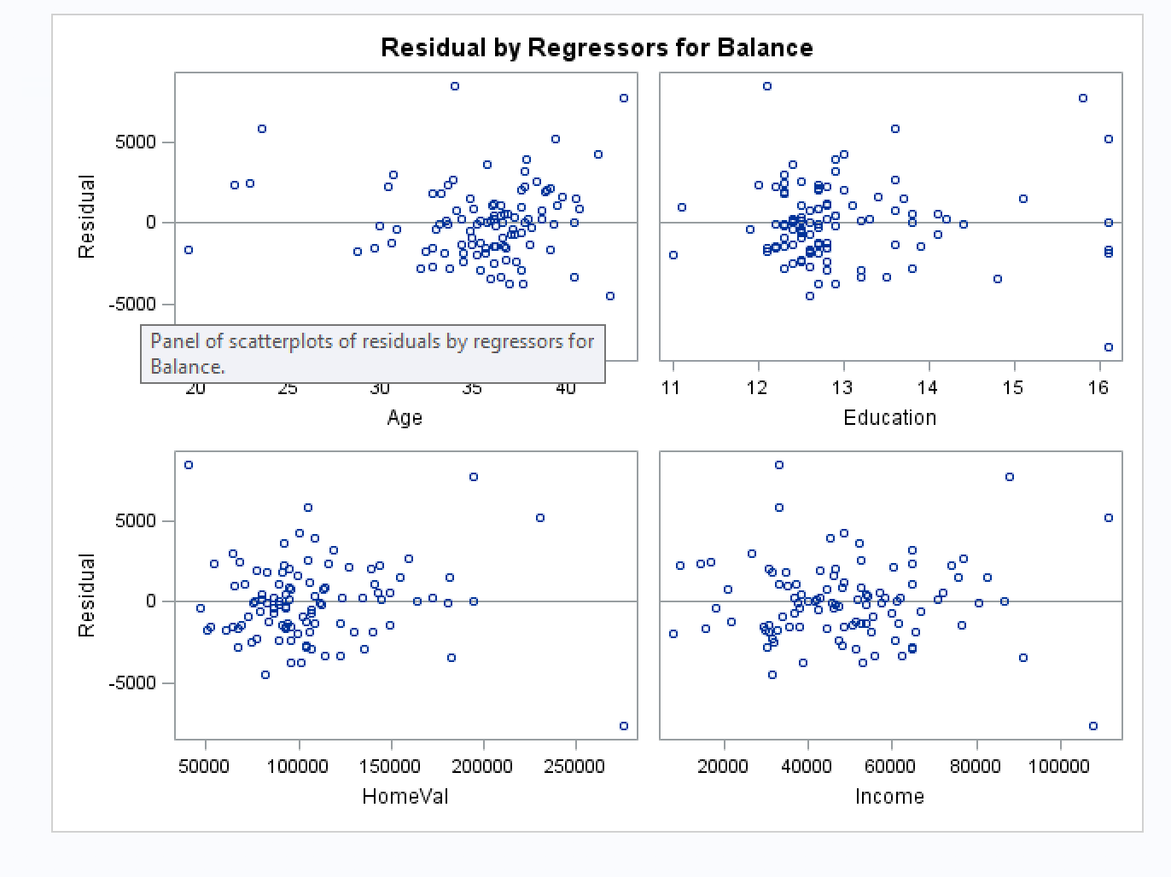

***Findings:***

*In the scatterplot from section a) of Question 2, I noted that there may be a slight curve with the plots for Balance*Education, and Balance*Age. The other variables do not seem to violate linearity. I am wondering if outliers or influential points are skewing the line so I will recheck residuals after I check for outliers and influential points.*

*M1 findings:*

*I see that there is evidence of outliers in the standard residuals plot against the predicted value. In looking at the standardized residuals against the x variables, I can see that most do not violate constant variation and independence in that they are scattered about the zero line, although Education may have a pattern therefore it would be violating constant variation and independence. Normality may be violated as well because there is a slight s-curve on the Normal cumulative distribution line. I will need to check for outliers and influential points to see if this fixes these violations.*

*M2 findings:*

*I can see from the output of M2 without Income that the normal probability curve takes on a somewhat strange appearance with the tails getting slightly larger. I still see similar violations of constant variance and independence as I did with M1 in both M2 models with regards to Education variable but in the residual plots, I’m also noticing that Wealth may have a funnel pattern as well. When I look at the residual plots with Wealth removed, I see more evenly scattered points about the mid-line. Both of the M2 models show some normality violation in that the normal probability plot line is slightly curved. Perhaps this will be fixed with the removal of the outliers.*

* 1. Analyze if there are any outliers and/or influential points for your model. If so, what actions would you take to address this issue? Make sure to implement any actions you specify here. Include the relevant output.

***Answer:***

*At this point, I’m assuming that I’m only checking for influential points and outliers for M2. I will choose to drop Wealth and include Income in our dataset because it is a more common variable used. I will do the following outliers and influential points removal for M2 with Wealth removed as my model.*

***Code:***

*\*regression model to check for outliers and influential points M1;*

*TITLE 'M1 Regression Analysis for bankingfull_new: Outlier/Influential Points';*

*PROC REG data=bankingfull_new;*

*MODEL Balance=Age Education HomeVal Income /vif influence r;*

*\*residual plots;*

*PLOT student.*predicted.;*

*PLOT student.*(Age Education HomeVal Income);*

*PLOT npp.*student.;*

*run;*

***Output:***

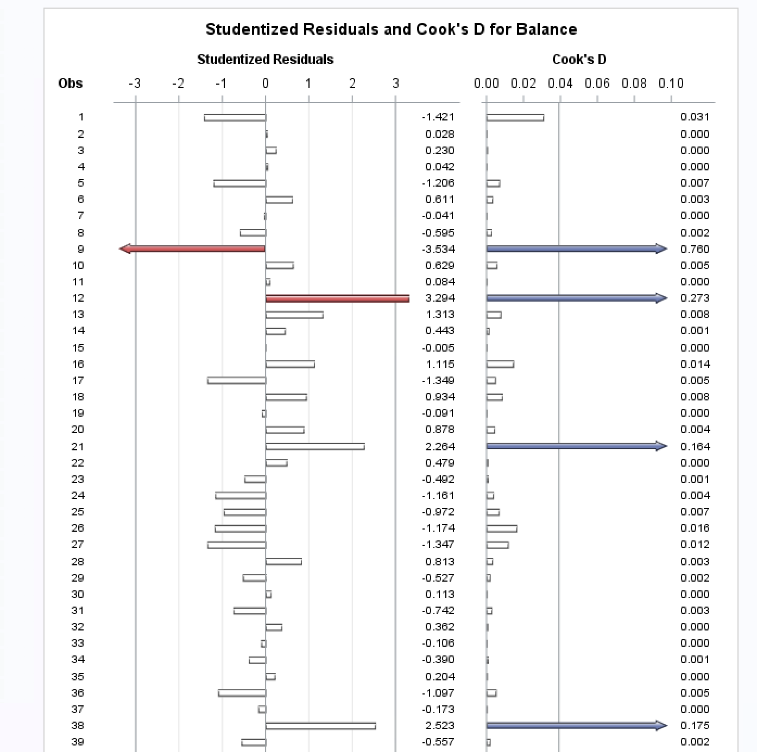

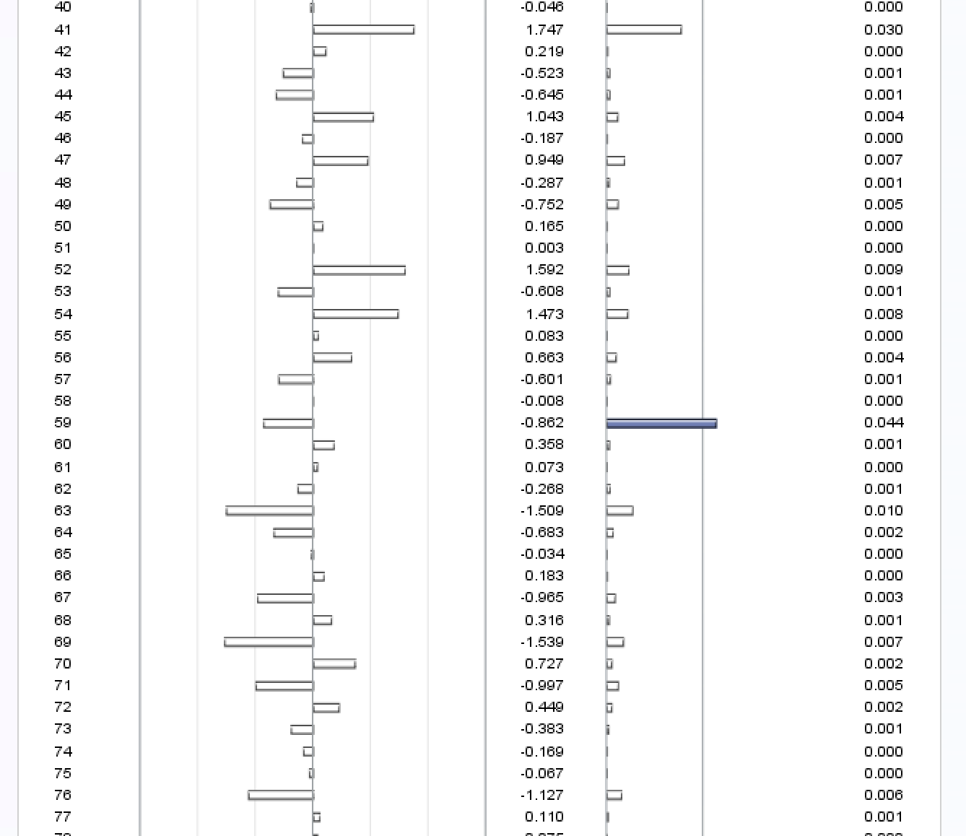

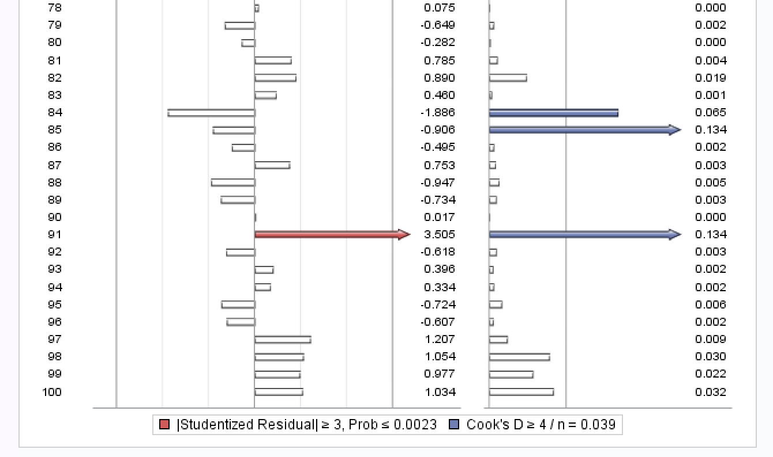

*I can see that there are two points of most interest because they are showing up as outliers and influential points. I will start by removing 91 and then recheck.*

*\*dropping outliers and influential points;*

*TITLE 'M2 with outlier and influential point removed';*

*data bankingfull_new1;*

*set bankingfull_new;*

*\* remove 91st observation;*

*if _n_=91 then delete;*

*run;*

*\*regression model M2 without 91;*

*TITLE 'M2 Regression Analysis with removed points';*

*PROC REG data=bankingfull_new1;*

*MODEL Balance=Age Education HomeVal Income /vif influence r;*

*\*residual plots;*

*PLOT student.*predicted.;*

*PLOT student.*(Age Education HomeVal Income);*

*PLOT npp.*student.;*

*run;*

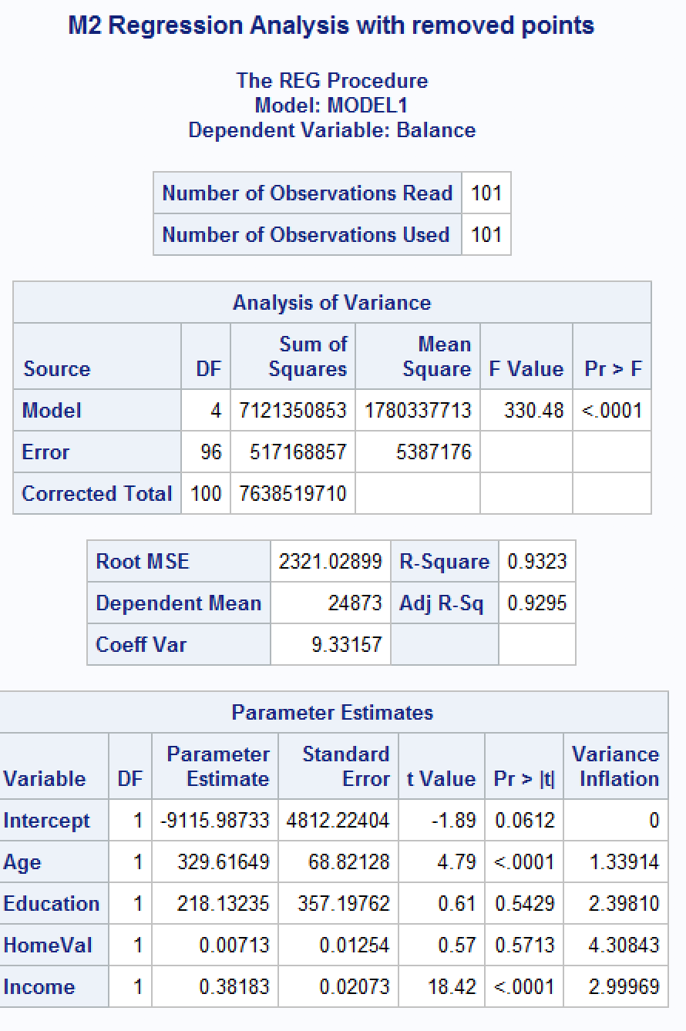

*I can see that R2 and Adj R2 have both improved with the removal of the one outlier/influential point. I still see that there are a few more outliers/influential points. I will continue to remove one at a time:*

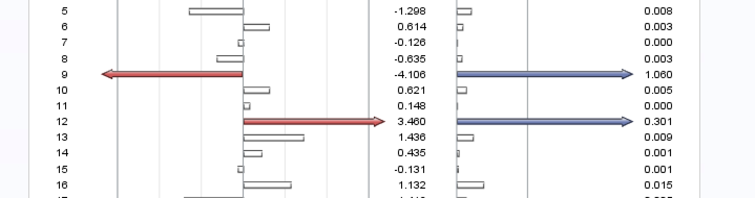

*Point 9 looks like it has the highest values so I will remove that one first.*

*\*dropping outliers and influential points;*

*TITLE 'M2 with outlier and influential point removed';*

*data bankingfull_new2;*

*set bankingfull_new1;*

*if _n_=9 then delete;*

*run;*

*\*regression model M2 without 91;*

*TITLE 'M2 Regression Analysis with removed points';*

*PROC REG data=bankingfull_new2;*

*MODEL Balance=Age Education HomeVal Income /vif influence r;*

*\*residual plots;*

*PLOT student.*predicted.;*

*PLOT student.*(Age Education HomeVal Income);*

*PLOT npp.*student.;*

*run;*

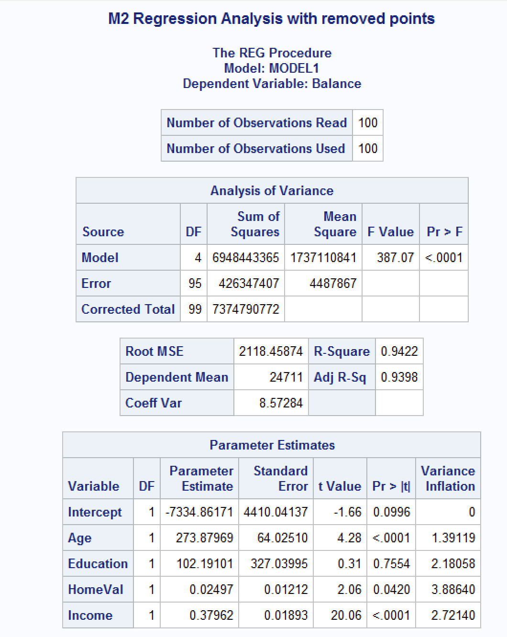

*R2 and Adj R2  have continued to improve, I also see that F-Value has increased, RMSE has decreased so I am seeing indicators that the model is continuing to improve.*

*I still see a point – 11, that is showing signs of being an outlier and influential point. I will remove this point as well, although I am cautious because I know that it was mentioned in class that too many removals can lead to more outliers and influential points so I will keep this in mind.*

*\*dropping outliers and influential points;*

*TITLE 'M2 with outlier and influential point removed';*

*data bankingfull_new3;*

*set bankingfull_new2;*

*if _n_=11 then delete;*

*run;*

*\*regression model M2 without r influence;*

*TITLE 'M2 Regression Analysis with removed points';*

*PROC REG data=bankingfull_new3;*

*MODEL Balance=Age Education HomeVal Income /vif influence r;*

*\*residual plots;*

*PLOT student.*predicted.;*

*PLOT student.*(Age Education HomeVal Income);*

*PLOT npp.*student.;*

*run;*

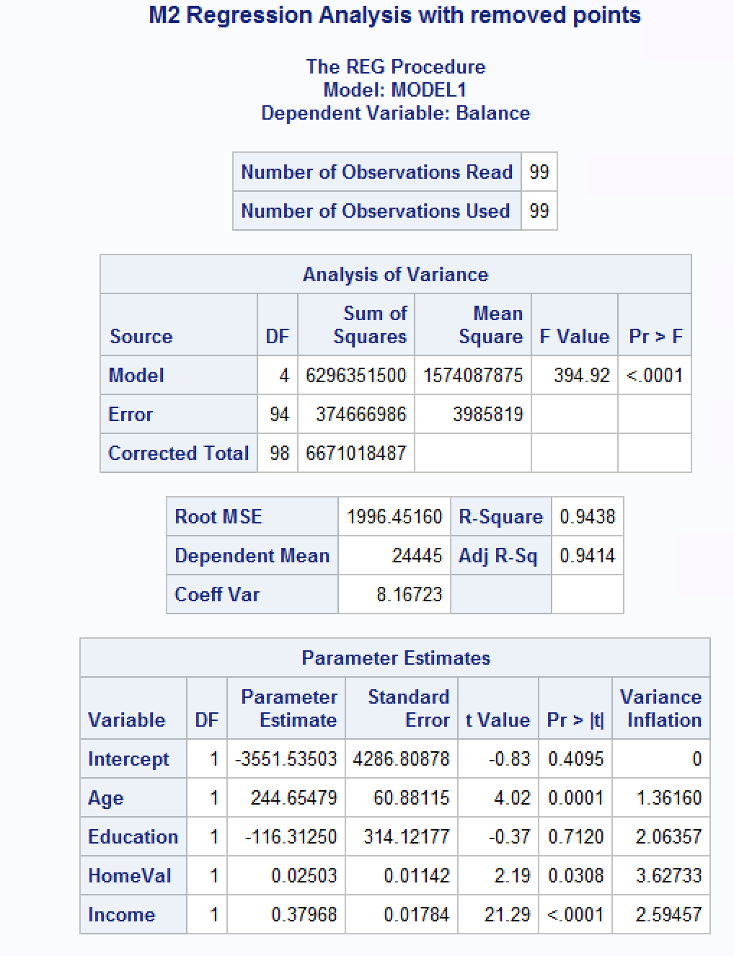

*I’m still seeing improvement in all the above statistics, although now I do not have any outliers, I just see influential points.*

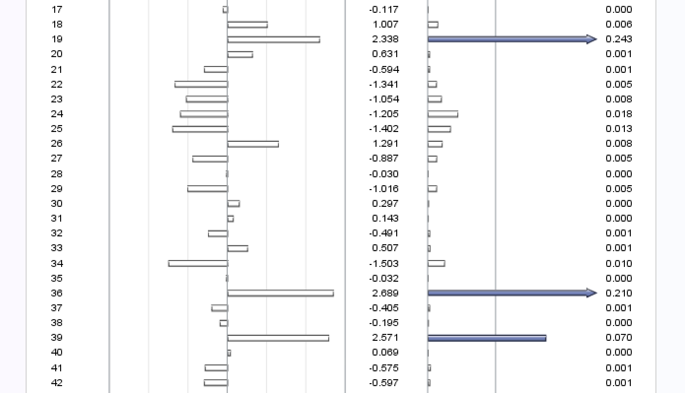

*I will remove 19 and recheck.*

*\*dropping outliers and influential points;*

*TITLE 'M2 with outlier and influential point removed';*

*data bankingfull_new4;*

*set bankingfull_new3;*

*if _n_=19 then delete;*

*run;*

*\*regression model M2 without r influence;*

*TITLE 'M2 Regression Analysis with removed points';*

*PROC REG data=bankingfull_new4;*

*MODEL Balance=Age Education HomeVal Income /vif influence r;*

*\*residual plots;*

*PLOT student.*predicted.;*

*PLOT student.*(Age Education HomeVal Income);*

*PLOT npp.*student.;*

*run;*

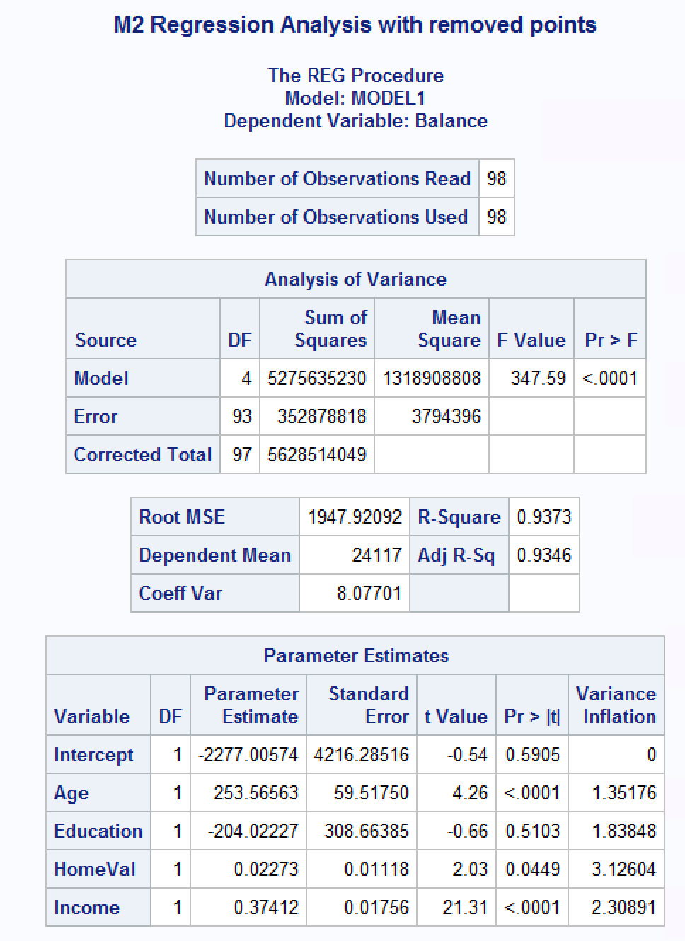

*I’m seeing that some of the statistics have stopped improving after this move. I still see two influential points. I will remove one more to see what happens - 35*

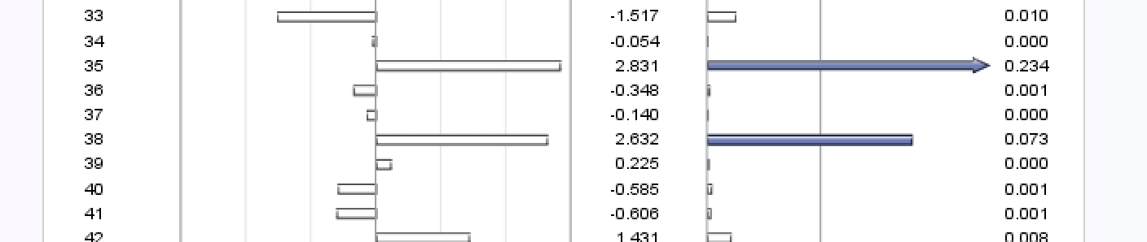

*dropping outliers and influential points;

TITLE 'M2 with outlier and influential point removed';

data bankingfull_new5;

set bankingfull_new4;

if _n_=35 then delete;

run;

*regression model M2 without r influence;

TITLE 'M2 Regression Analysis with removed points';

PROC REG data=bankingfull_new5;

MODEL Balance=Age Education HomeVal Income /vif influence r;

*residual plots;

PLOT student.*predicted.;

PLOT student.*(Age Education HomeVal Income);

PLOT npp.*student.;

run;

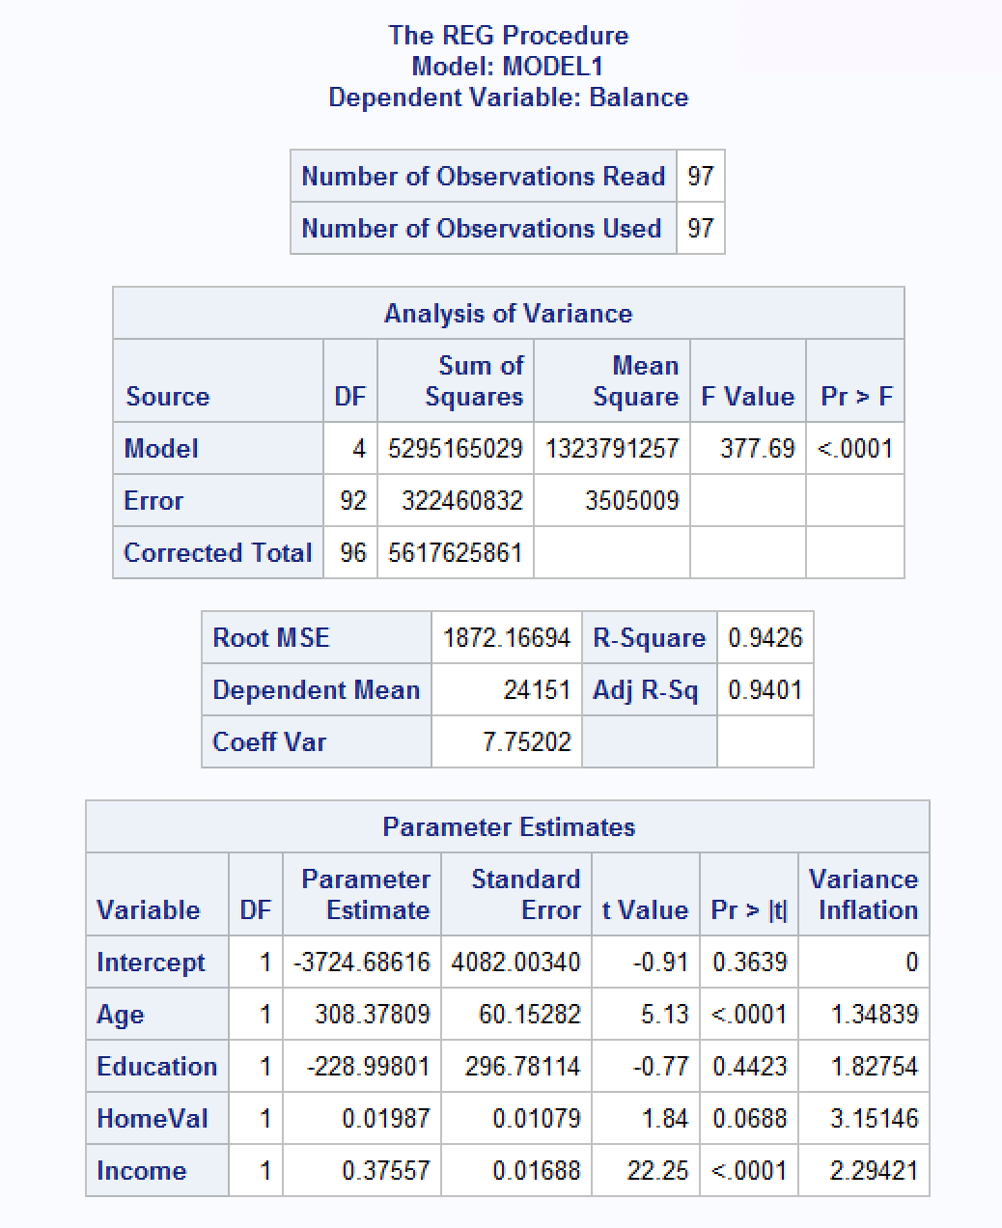

*Once again, seeing improvement. A couple more influential points popped up but one that has continued to be there is 97. I will remove 97 and hopefully this will be enough.*

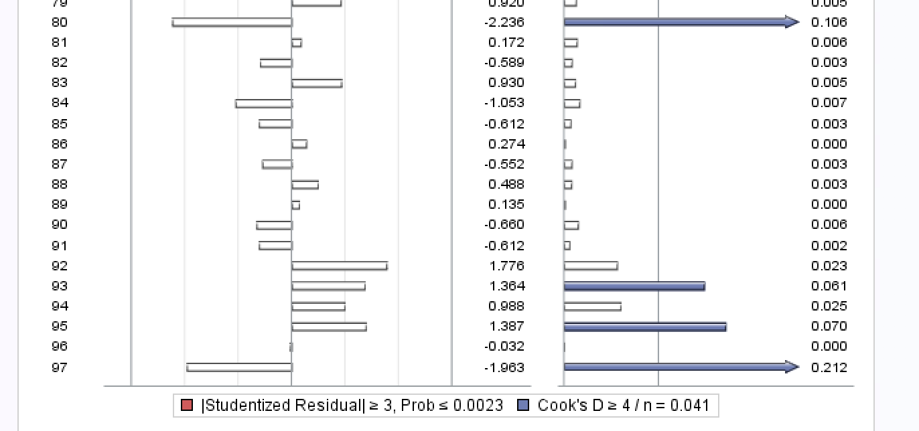

*\*dropping outliers and influential points;*

*TITLE 'M2 with outlier and influential point removed';*

*data bankingfull_new6;*

*set bankingfull_new5;*

*if _n_=97 then delete;*

*run;*

*\*regression model M2 without r influence;*

*TITLE 'M2 Regression Analysis with removed points';*

*PROC REG data=bankingfull_new6;*

*MODEL Balance=Age Education HomeVal Income /vif influence r;*

*\*residual plots;*

*PLOT student.*predicted.;*

*PLOT student.*(Age Education HomeVal Income);*

*PLOT npp.*student.;*

*run;*

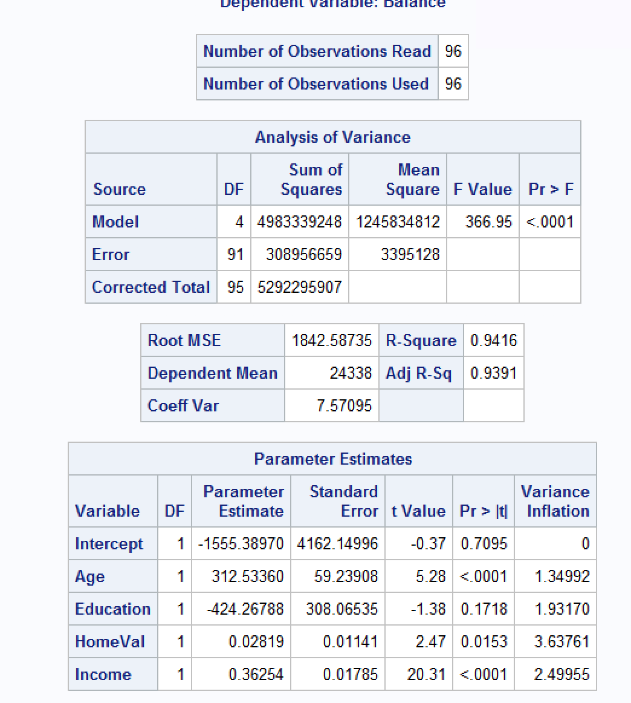

*Although the R2 and Adj R2  have dropped slightly, there is still one influential point with an arrow. I will remove that last one, recheck and if statistics do not improve or if more influential points are introduced, I will not remove it in the final model. I will remove 80.*

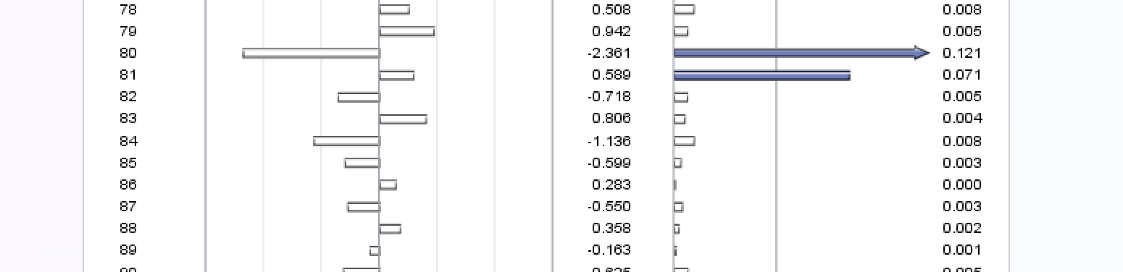

*\*dropping outliers and influential points;*

*TITLE 'M2 with outlier and influential point removed';*

*data bankingfull_new7;*

*set bankingfull_new6;*

*if _n_=80 then delete;*

*run;*

*\*regression model M2 without r influence;*

*TITLE 'M2 Regression Analysis with removed points';*

*PROC REG data=bankingfull_new7;*

*MODEL Balance=Age Education HomeVal Income /vif influence r;*

*\*residual plots;*

*PLOT student.*predicted.;*

*PLOT student.*(Age Education HomeVal Income);*

*PLOT npp.*student.;*

*run;*

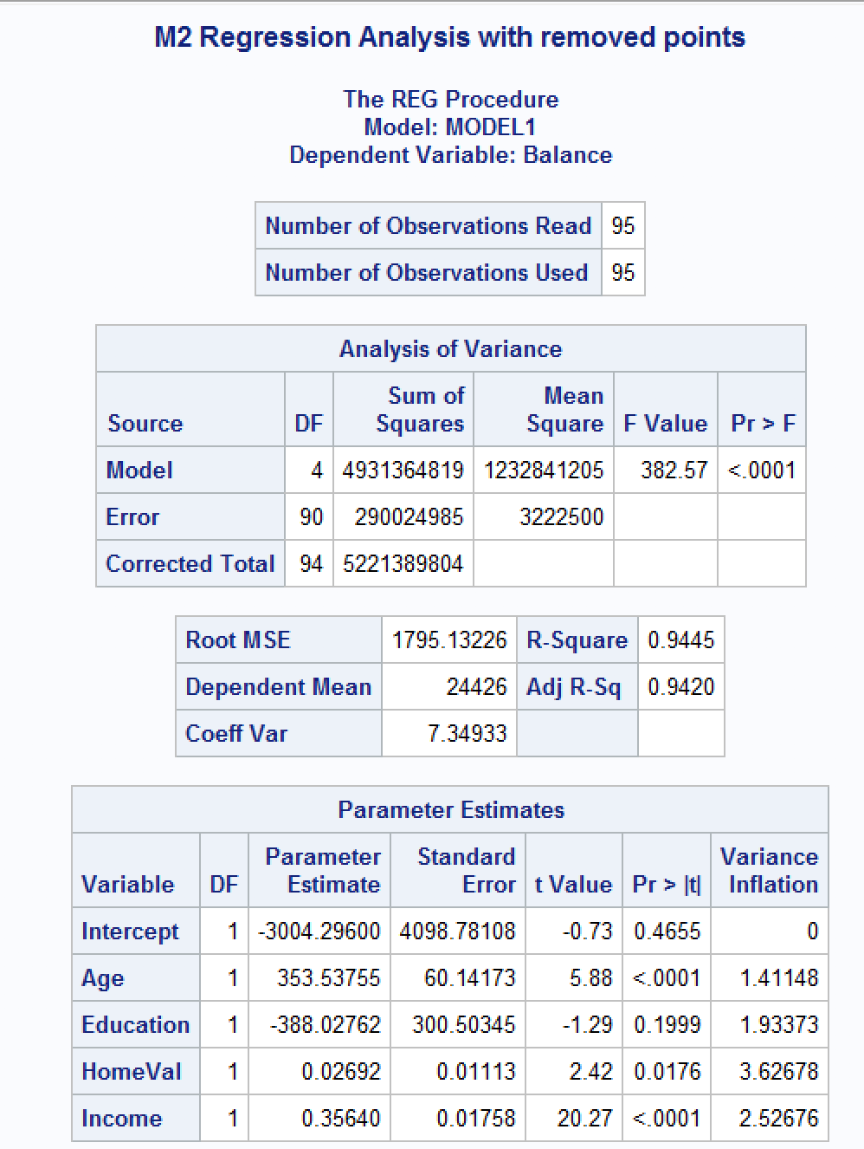

*I’m still seeing improvements and another point with arrow has appeared, I will give this one more try and then I will move on. – this is point 80 now.*

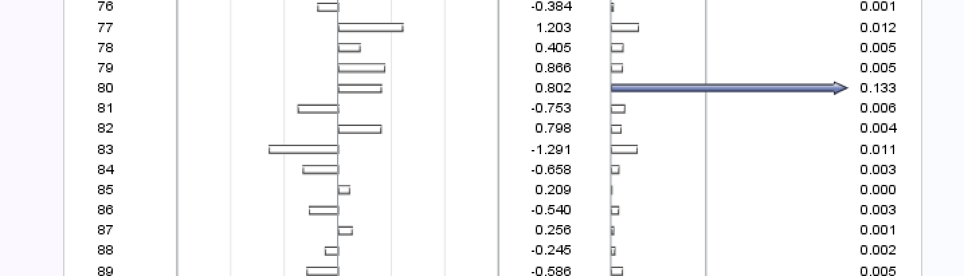

*When I removed the last influential point, more influential points showed up and the statistics for goodness of fit of the model decreased slightly. So I will not include this last removal in my final model.*

* 1. Compute the standardized coefficients and discuss which predictor has the strongest influence on balance? Include the relevant output.

***Answer:***

*I am repasting the final model regression analysis without outliers and influential points to answer this question:*

**

*I can see in this model that Education is an insignificant variable so I will remove it and then compute standardized coefficients.*

*\*Final model with Education removed;*

*TITLE 'M2 Regression Analysis with removed points';*

*PROC REG data=bankingfull_new7;*

*MODEL Balance=Age HomeVal Income /stb vif influence r;*

*\*residual plots;*

*PLOT student.*predicted.;*

*PLOT student.*(Age HomeVal Income);*

*PLOT npp.*student.;*

*run;*

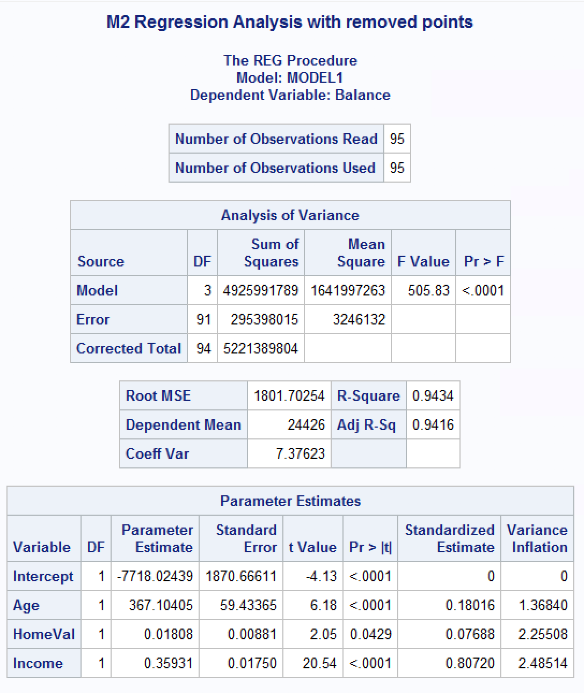

*I see that all the variables in the final model are significant with p-values < 0.005. The most significant predictor of Balance is Income and then Age and then HomeVal. The final fitted model is:*

*Balance = -7718.02439 + 367.10405(Age) + 0.01808(HomeVal) + 0.35931(Income)*

***Overall Findings:***

*F-value is high and R2 and AdjR2 are at approximately 94%. Therefore, we have a good model that accounts for 94% of the variability of Balance.*

*I created a scatterplot of our new data to check for linearity:*

*\*Scatter plots for bankingfull;*

*TITLE 'Scatterplot matrix for bankingfull data';*

*PROC SGSCATTER data=bankingfull_new7;*

*MATRIX Age Income HomeVal Balance;*

*RUN;*

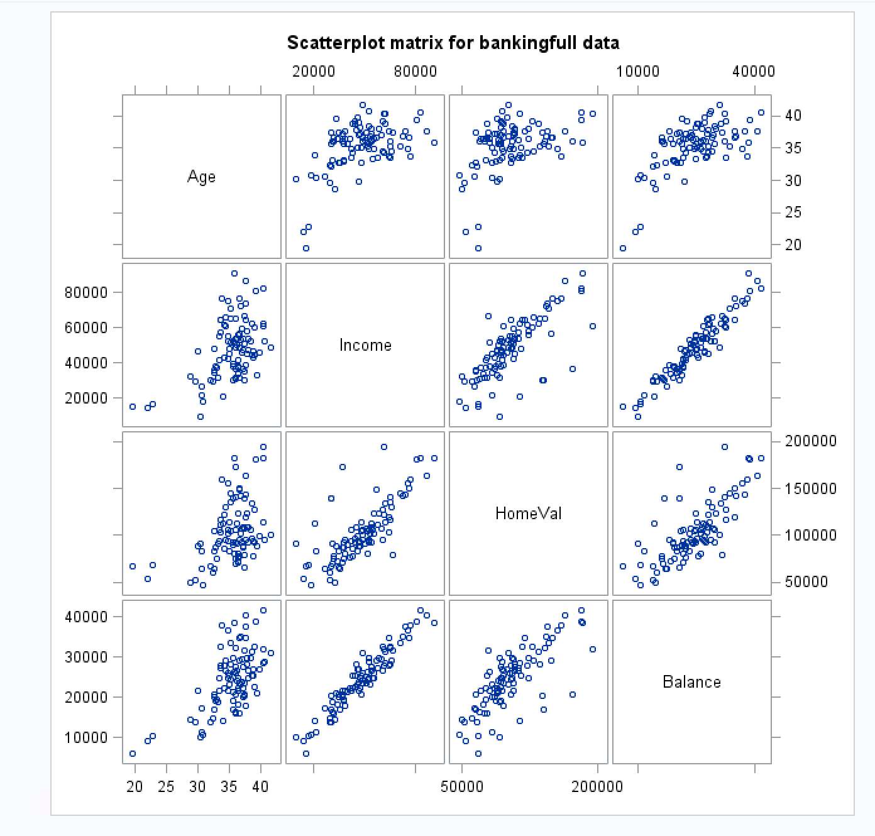

*I see improvement, although there may be still some influential points affecting Balance/Age. All the plots against Balance now look linear for the most part.*

*Also, when I look at the residual plots for our final model, I see that they have improved.*

*The normal probability plot is more flush to the line, and the points appear to be more evenly scattered about the midline for all the x-variables therefore constant variance and independence is no longer violated.*

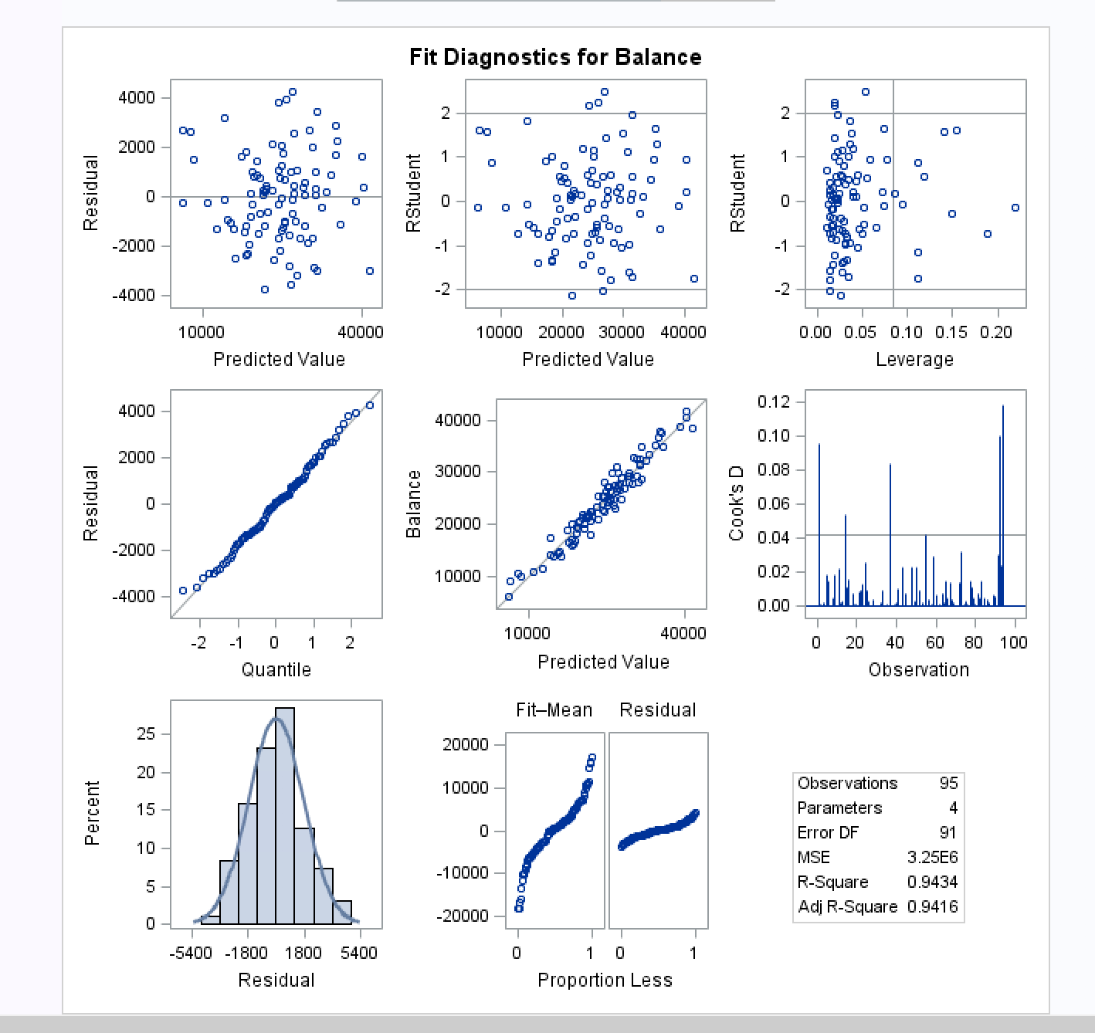

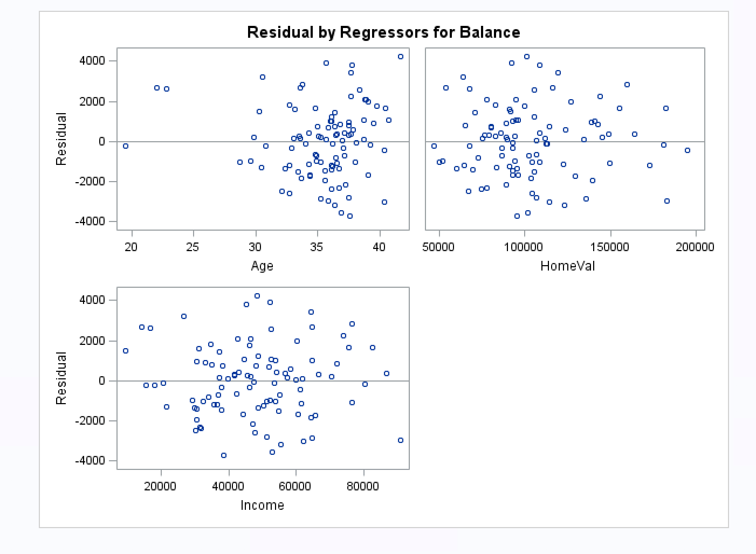

*Age may still be affected by some potentially influential points, however, it is more evenly scattered than before.*

* 1. Copy and paste your FULL SAS code into the word document along with your answers.

*Answer: see above code and output.*

**Problem 3 [10 pts] – to be answered by everyone**

Analytics is used in many different sports and has become popular with the Money Ball movie. The pgatour2006.csv dataset contains data about 196 tour players in 2006. The variables in the dataset are:

* Player’s name
* PrizeMoney = average prize money per tournament

And a set of metrics that evaluate the quality of a player’s game.

* DrivingAccuracy = percent of times a player is able to hit the fairway with his tee shot
* GIR = percent of time a player was able to hit the green within two or less than par (Greens in Regulation)
* BirdieConversion = percentage of times a player makes a birdie or better after hitting the green in regulation
* PuttingAverage = putting performance on those holes where the green was hit in regulation.
* PuttsPerRound= average number of putts per round (shots played on the green)

You are asked to build a model for PrizeMoney using the remaining predictors, and to evaluate the relative importance of each different aspects of a player’s game on the average prize money.

**Note:** For the non-golfers in the class, you can refer to this page for an explanation of the terms:

<http://en.wikipedia.org/wiki/Glossary_of_golf>

**SAS Code to Import the data**

*import data from file;

**proc** **import** datafile="pgatour2006.csv" out=myd replace;

delimiter=',';

getnames=yes;

**run**;

Note:

* The data file is in CSV format
* It is delimitered with a comma
* The SAS dataset it is writing into is myd. You can change the name if you like.

1. Create scatterplots to visualize the associations between PrizeMoney and the other 5 variables. Discuss the patterns displayed by the scatterplot. Also, explain if the associations appear to be linear? (you can create scatterplots or a matrix plot). Include the relevant output.

***Answer:***

***Code****:*

*\*import data from file;*

*proc import datafile="S:\CSC423\HW2\pgatour2006.csv" out=myd replace;*

*delimiter=',';*

*getnames=yes;*

*run;*

*proc print data=myd;*

*run;*

*\*Scatter plots for myd;*

*TITLE 'Scatterplot matrix for pgatour data';*

*PROC SGSCATTER data=myd;*

*MATRIX PrizeMoney DrivingAccuracy GIR PuttingAverage BirdieConversion PuttsPerRound;*

*RUN;*

***Output:***

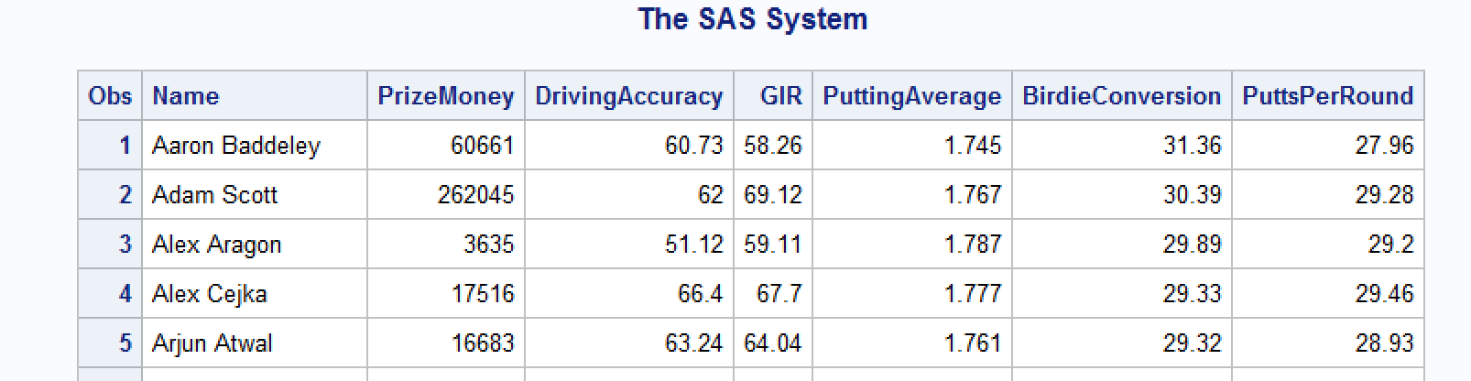

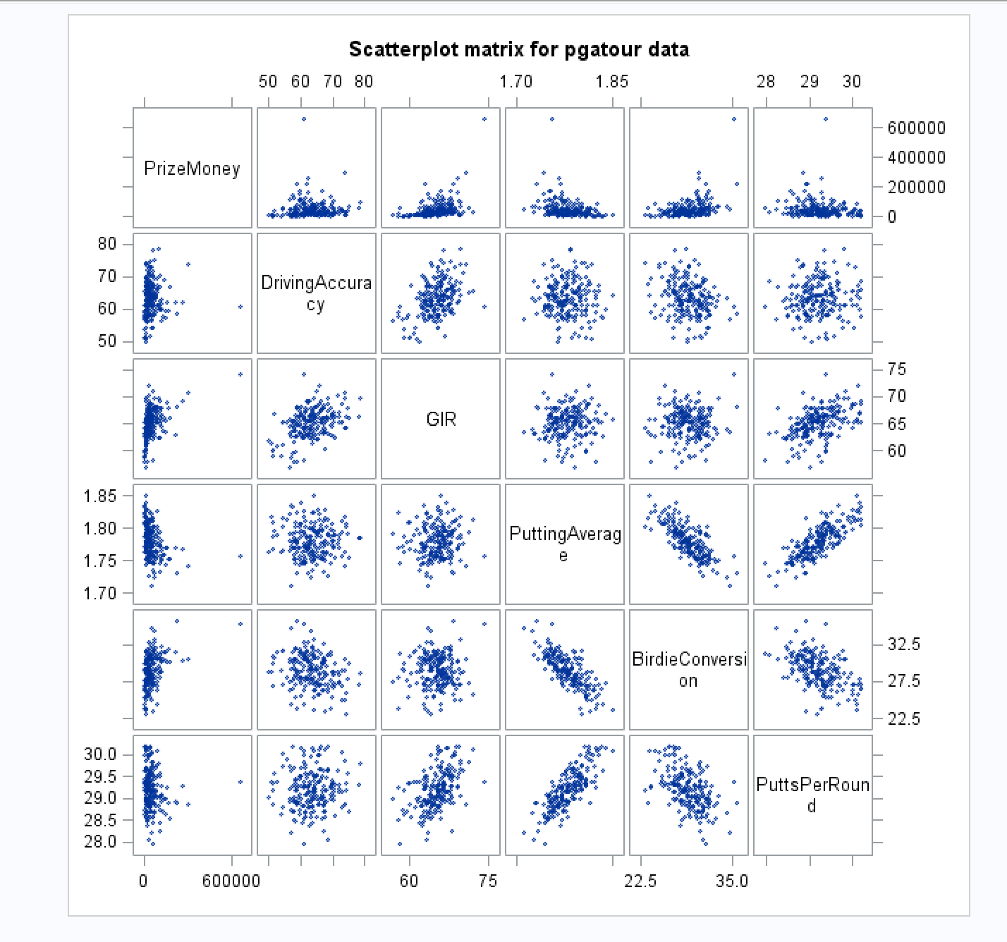

***Findings:***

*The plots between the predictor variables and PrizeMoney do not look linear to me. I’m guessing this may be a normalization issue in that the y-variable and/or x-varsiables will need to be transformed.*

1. Analyze distribution of PrizeMoney, and discuss if the distribution is symmetric or skewed. Include the relevant output.

***Answer****:*

***Code****:*

*\*Histogram and normal curve for PrizeMoney;*

*TITLE 'Histogram + normal curve for PrizeMoney';*

*proc univariate normal;*

*var PrizeMoney;*

*histogram / normal (mu = est sigma = est);*

*run;*

***Output:***

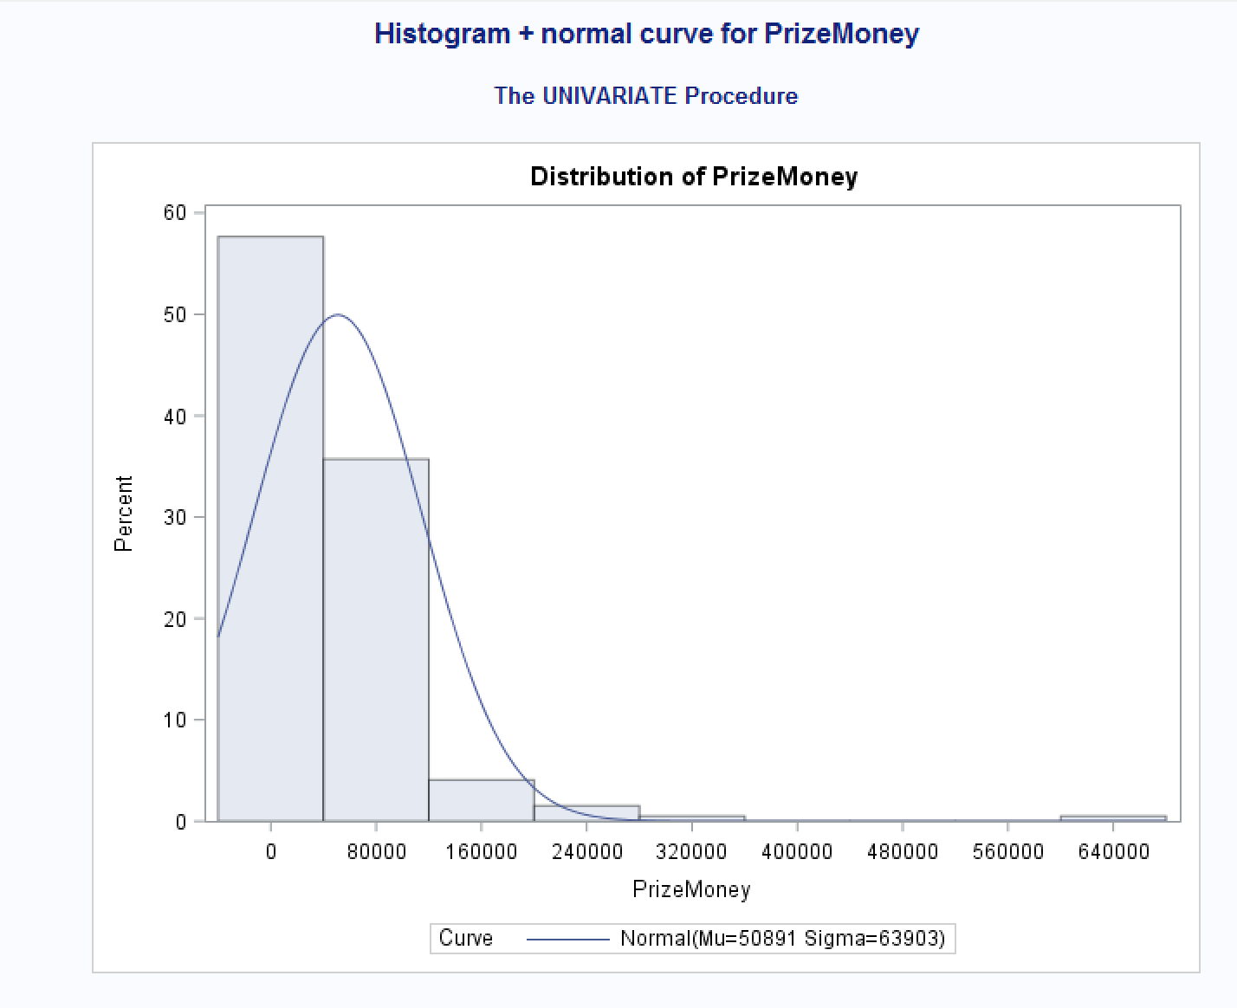

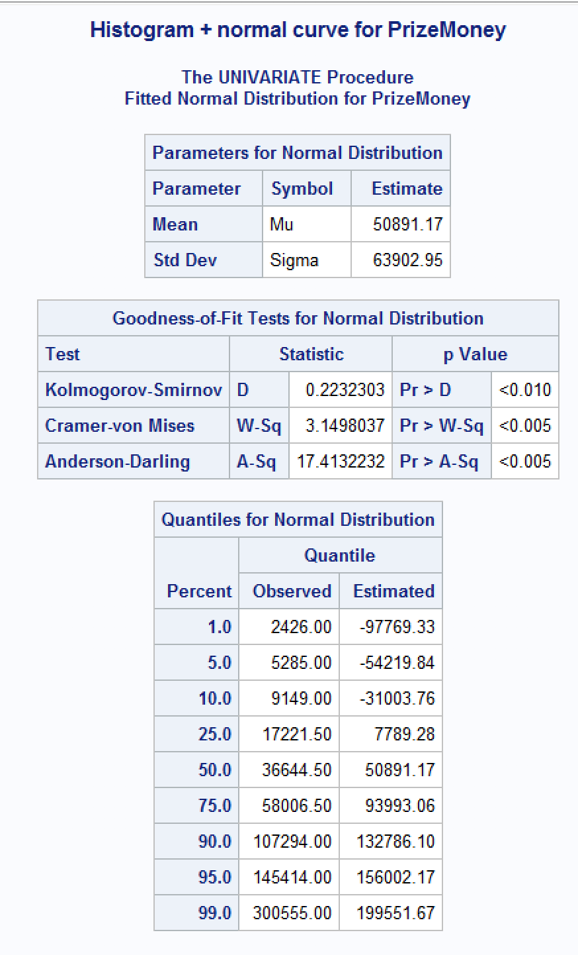

***Findings:***

*I can see that PrizeMoney is not normally distributed, it is right positively skewed as I can see from the histogram as well as from the mean being much larger than the median.*

1. Apply a log transformation to PrizeMoney and compute the new variable ln_Prize=log(PrizeMoney). Analyze distribution of ln_Prize, and discuss if the distribution is symmetric or skewed. Include the relevant output.

***Answer****:*

***Code****:*

*data myd;*

*\* set command copies original claim dataset;*

*set myd;*

*\*new lnclaim variable;*

*ln_Prize=log(PrizeMoney);*

*run;*

*proc print data=myd;*

*run;*

*\*Histogram and normal curve for ln_Prize;*

*TITLE 'Histogram + normal curve for ln_Prize';*

*proc univariate normal;*

*var ln_Prize;*

*histogram / normal (mu = est sigma = est);*

*run;*

***Output:***

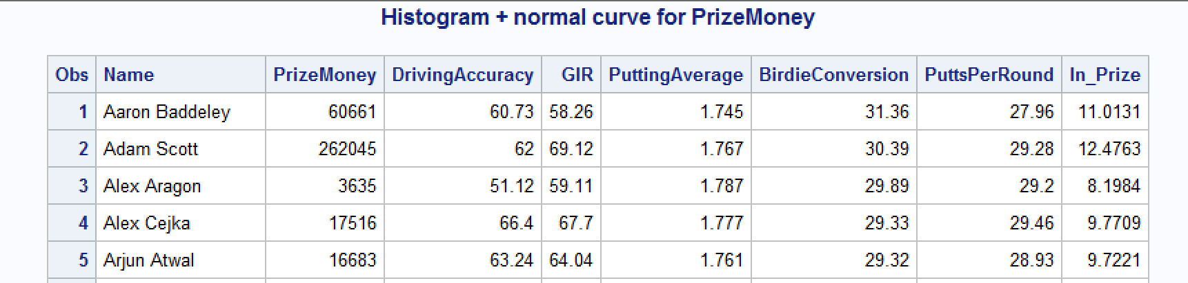

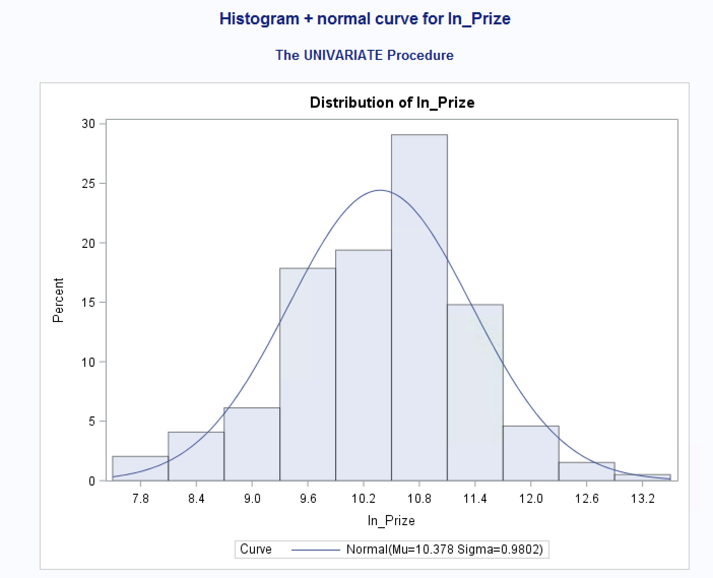

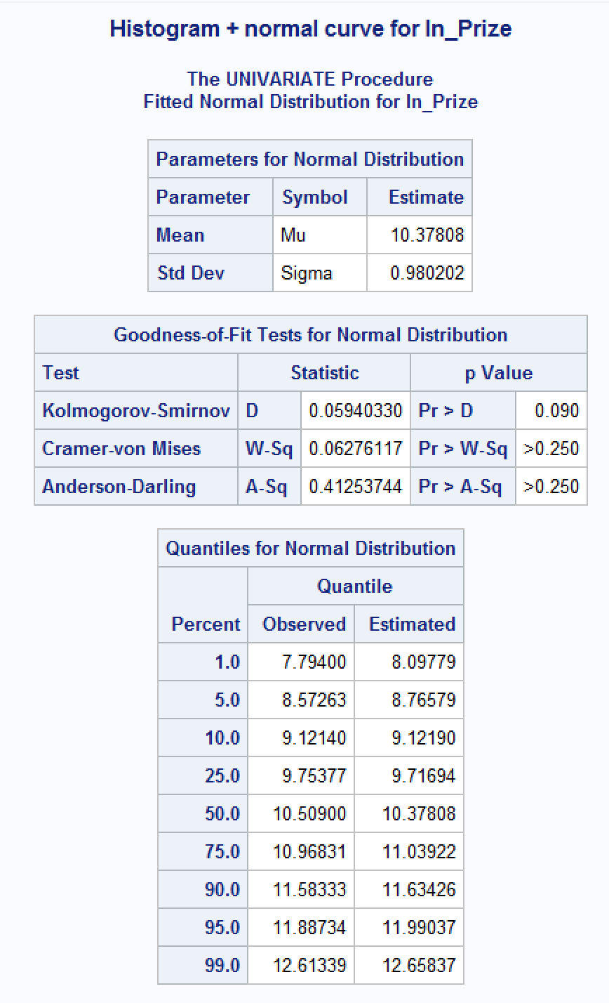

***Findings:***

*The new transformed ln_Prize is normally distributed as I can see from the histogram and by looking at the mean and median of the distribution, which are now very close in value.*

1. Fit a regression model of ln_Prize using the remaining predictors in your dataset. Apply your knowledge of regression analysis to define a valid model to predict ln_Prize. Include the outputs for all the questions below before you analyze them.

***Code for regression model:***

*\*regression model;*

*TITLE 'Regression Analysis using ln_Prize';*

*PROC REG data=myd;*

*MODEL ln_Prize=DrivingAccuracy GIR PuttingAverage BirdieConversion PuttsPerRound;*

*run;*

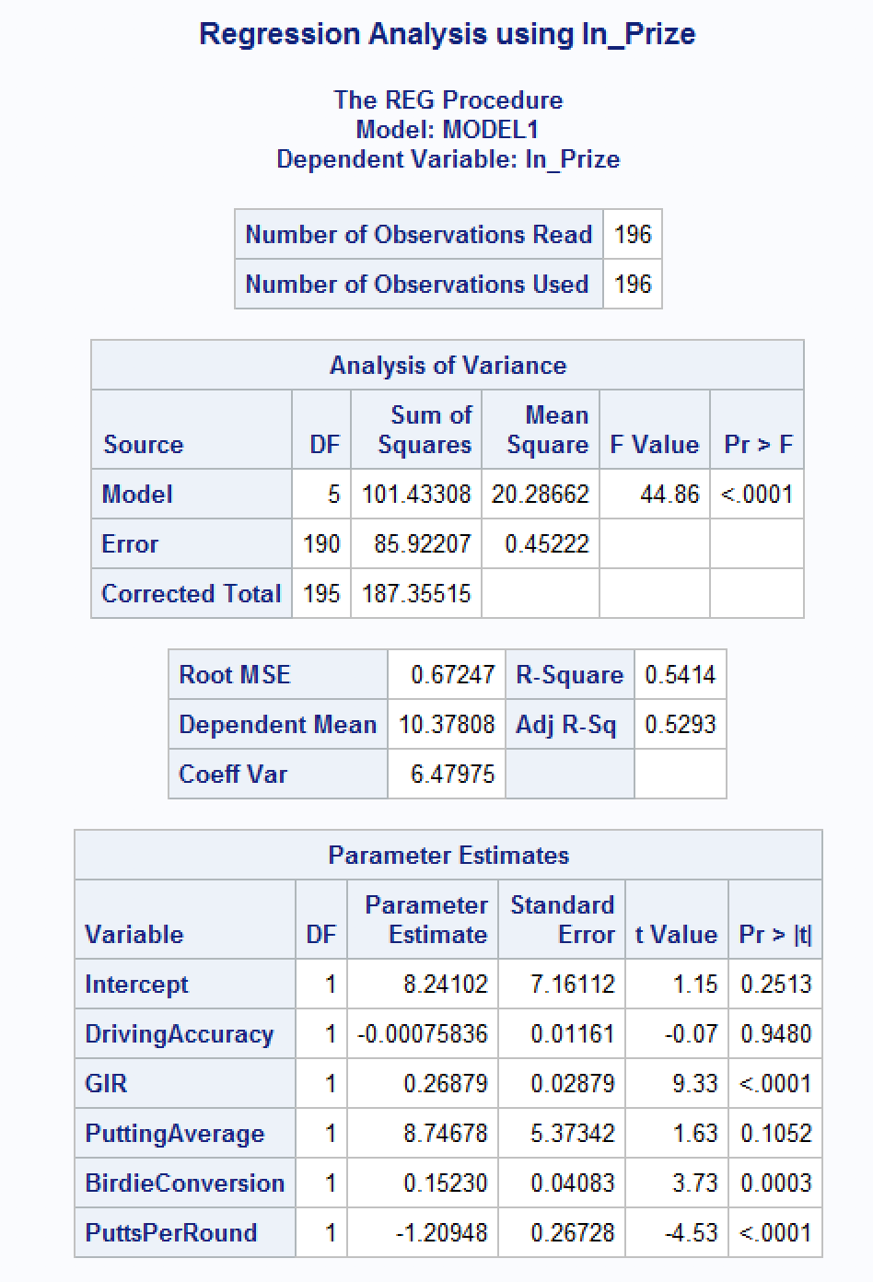

* + If necessary remove the non-significant variables. Remember to remove one variable at a time (variable with largest p-value is removed first) and refit the model, until all variables are significant.

***Answer:***

*I see that as of now there are two variables that are not significant for our model: DrivingAccuracy, and PuttingAverage. I will remove Driving Accuracy first because it has the highest p-value of 0.9480.*

***Code:***

*\*regression model;*

*TITLE 'Regression Analysis using ln_Prize';*

*PROC REG data=myd;*

*MODEL ln_Prize=GIR PuttingAverage BirdieConversion PuttsPerRound;*

*run;*

***Output:***

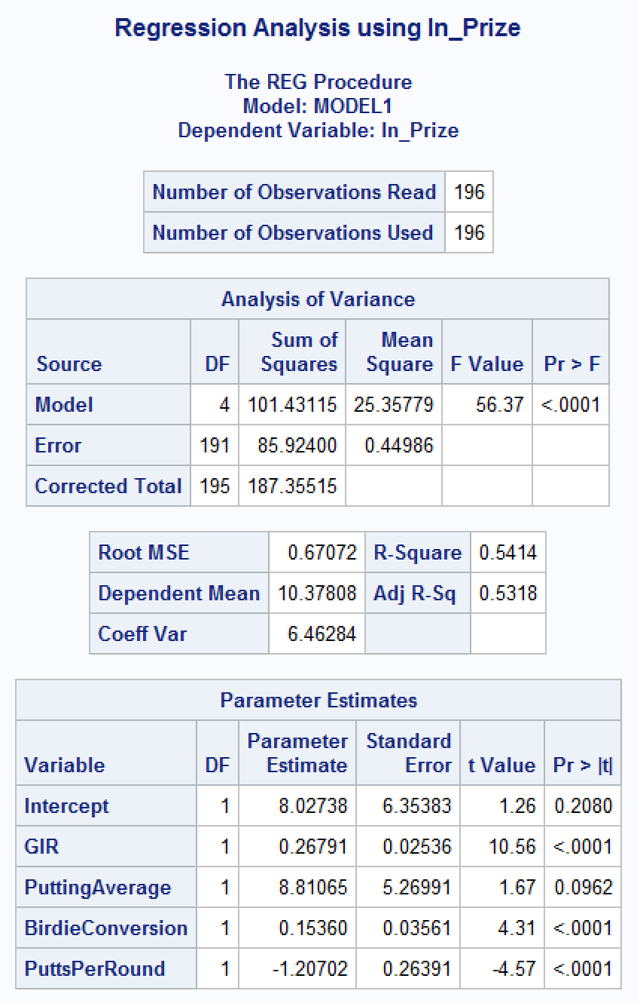

*The p-value for PuttingAverage is still larger than alpha=0.05 so I will not remove this variable as well for our model.*

***Code:***

*\*regression model with PuttingAverage and DrivingAccuracy removed;*

*TITLE 'Regression Analysis using ln_Prize minus PuttingAverage and DrivingAccuracy';*

*PROC REG data=myd;*

*MODEL ln_Prize=GIR BirdieConversion PuttsPerRound;*

*run;*

***Output:***

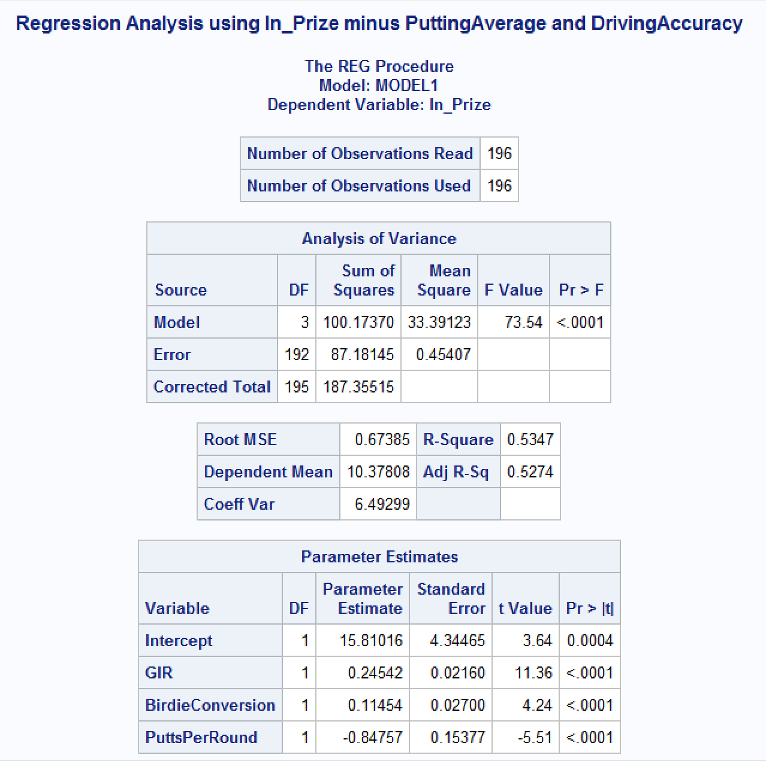

*Now all of the predictor variables are significant in our model.*

* + Analyze residual plots to check if the regression model is valid for your data. Discuss your analysis.

***Answer:***

***Code:***

*\*regression model with residual plots;*

*TITLE 'Regression Analysis with residual plots';*

*PROC REG data=myd;*

*MODEL ln_Prize=GIR BirdieConversion PuttsPerRound;*

*\*residual plots;*

*PLOT student.*predicted.;*

*PLOT student.*(GIR BirdieConversion PuttsPerRound);*

*PLOT npp.*student.;*

*run;*

*\*\*adding updated scatterplot to check for linearity\*\**

*\*Scatter plots for myd;*

*TITLE 'Scatterplot matrix for pgatour data';*

*PROC SGSCATTER data=myd;*

*MATRIX ln_Prize GIR BirdieConversion PuttsPerRound;*

*RUN;*

***Output:***

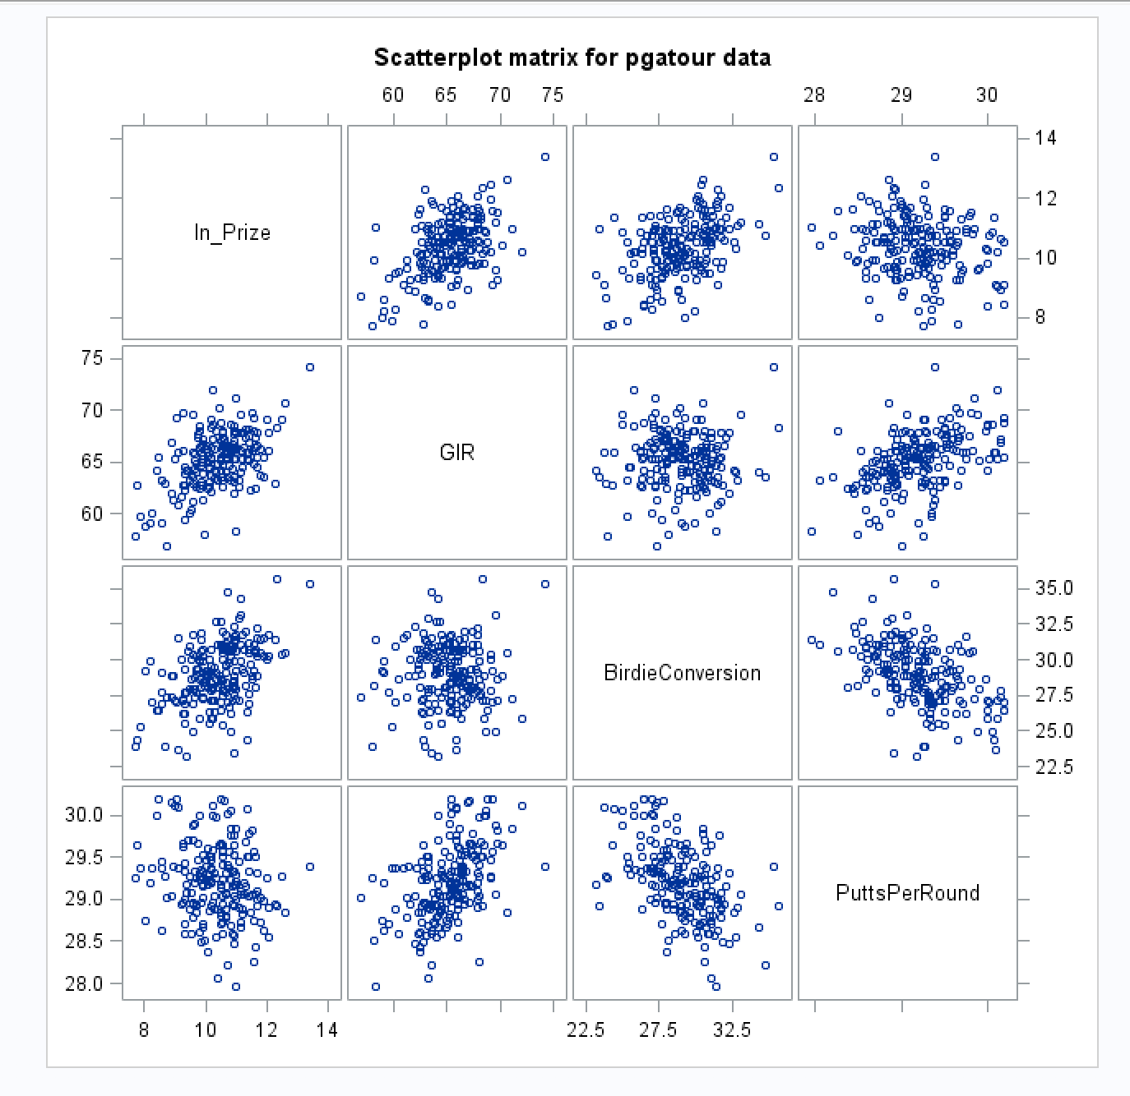

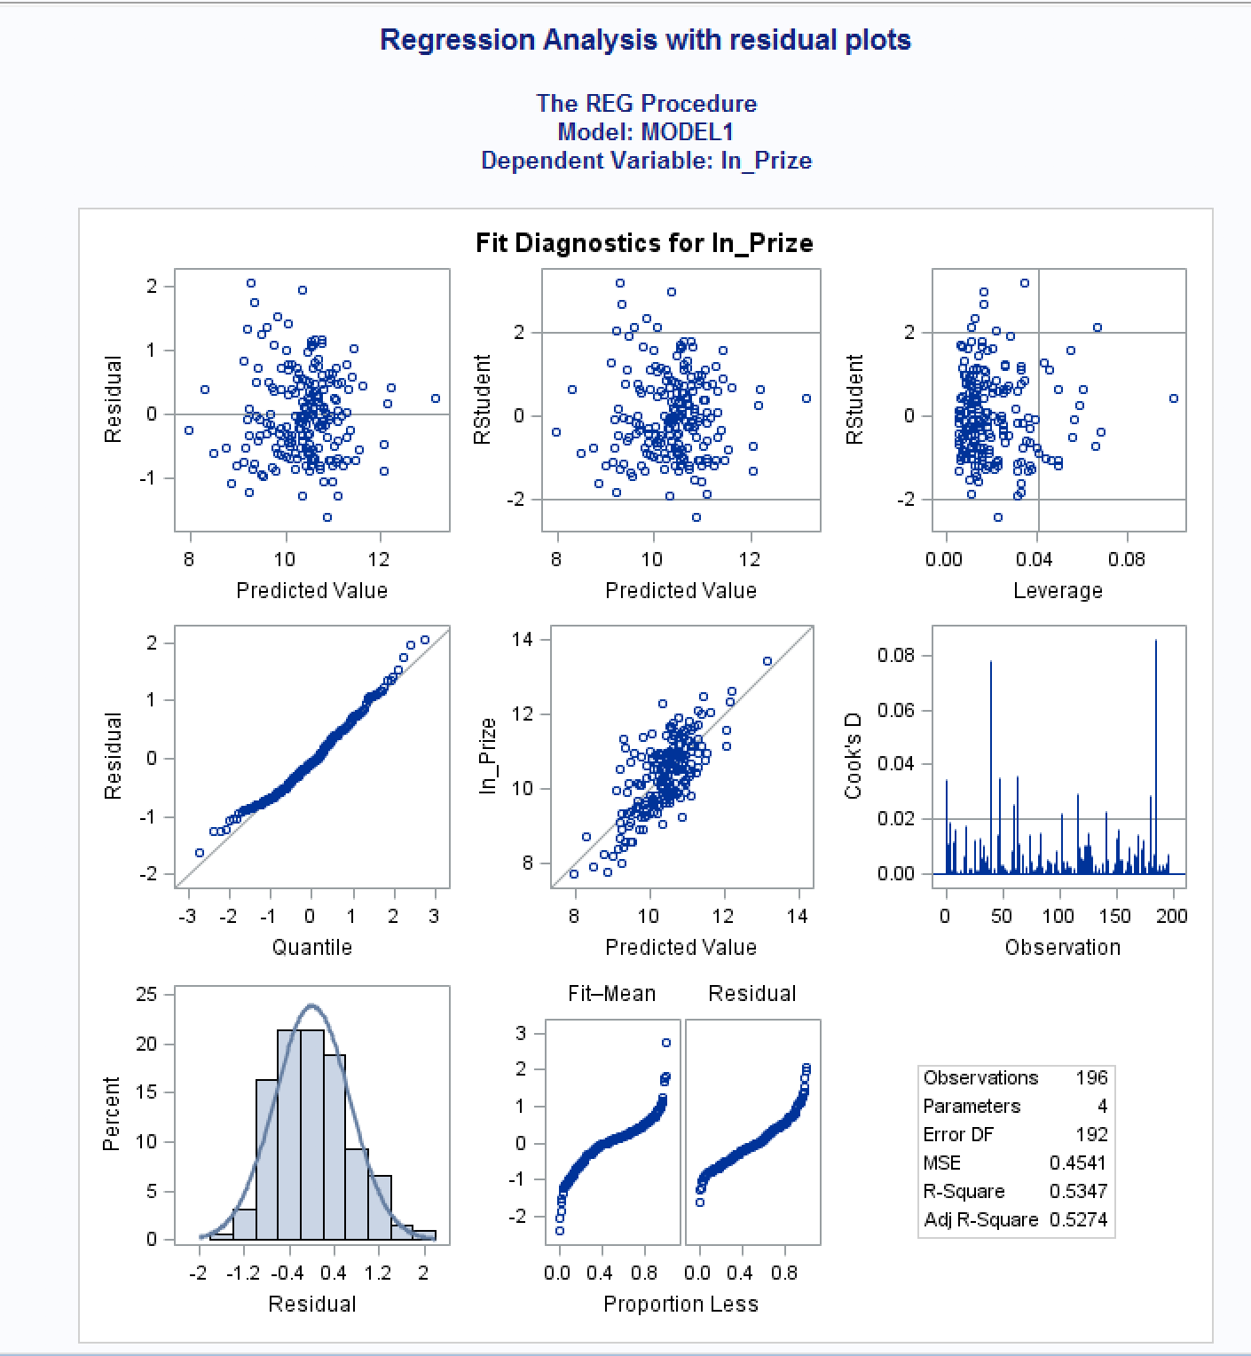

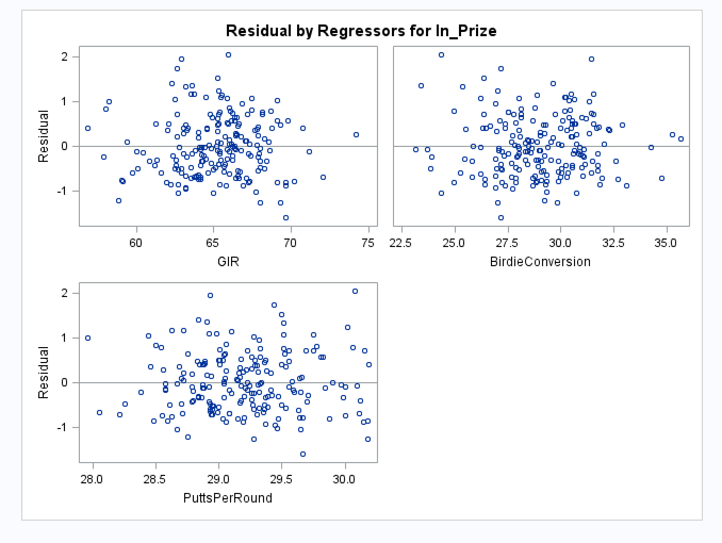

***Findings:***

*I reran scatterplots for the updated transformed y-variable and significant predictor variables. They are now all showing evidence of linearity. The residual plots for the x variables show evenly scattered points around the midline which tells me that our model does not violate constant variance and independence. The normal probability plot shows a slight curve which is likely the result of some outliers or influential points so as of now, our model violates normality.*

* + Analyze if there are any outliers and/or influential points. If there are points in the dataset that need to be investigated, give one or more reason to support each point chosen. Take appropriate action(s) to implement it. Include the relevant outputs. Discuss your answer.

***Answer:***

***Code:***

*\*regression model on myd - outliers and influential points;*

*TITLE 'Regression Analysis to view outliers and influential points';*

*PROC REG data=myd;*

*MODEL ln_Prize=GIR BirdieConversion PuttsPerRound / influence r;*

*\*residual plots;*

*PLOT student.*predicted.;*

*PLOT student.*(GIR BirdieConversion PuttsPerRound);*

*PLOT npp.*student.;*

*run;*

***Output:***

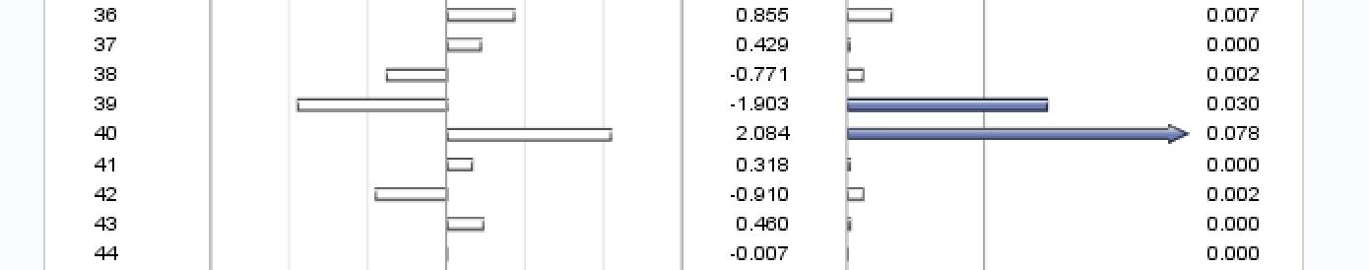

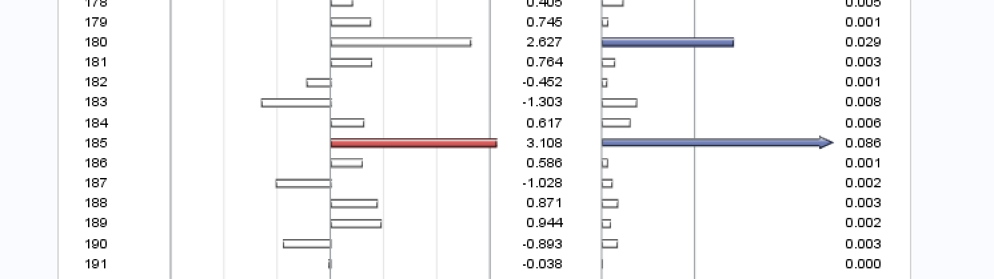

*There are two points that I would like to investigate to see if removing them will improve the model. I will start with the point at row 185 because this one is on the edge of being an outlier and it is also an influential point as I can see with the blue arrow on the right side. I will start by removing this point and seeing if the model is affected.*

***Code:***

*\*dropping outliers and influential points;*

*TITLE 'mydwith outlier and influential point removed';*

*data myd_new;*

*set myd;*

*if _n_=185 then delete;*

*run;*

*\*regression model on myd - outliers and influential points;*

*TITLE 'Regression Analysis with outliers and influential points removed';*

*PROC REG data=myd_new;*

*MODEL ln_Prize=GIR BirdieConversion PuttsPerRound / influence r;*

*\*residual plots;*

*PLOT student.*predicted.;*

*PLOT student.*(GIR BirdieConversion PuttsPerRound);*

*PLOT npp.*student.;*

*run;*

***Output:***

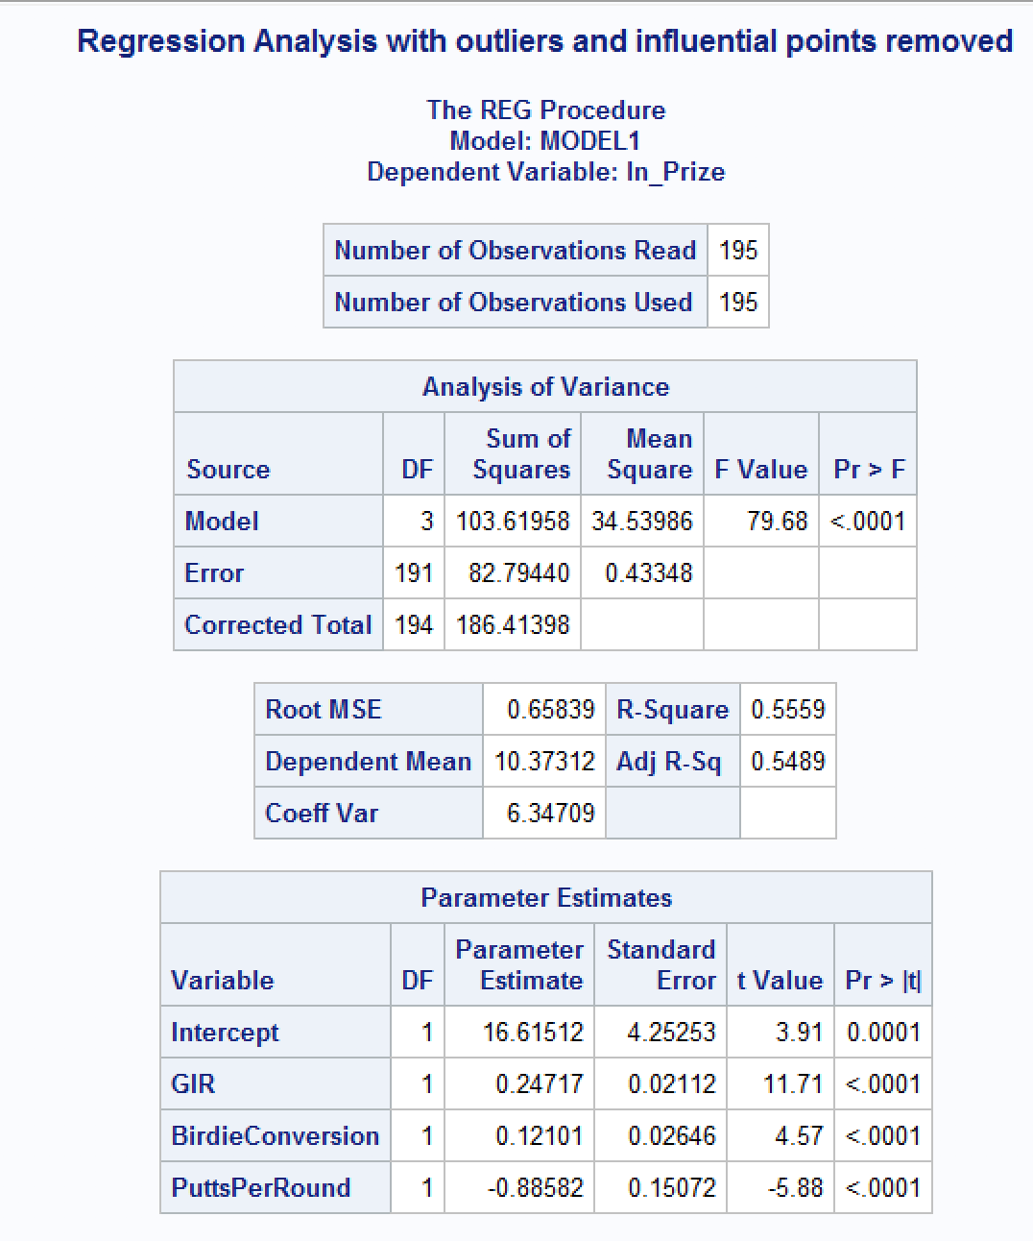

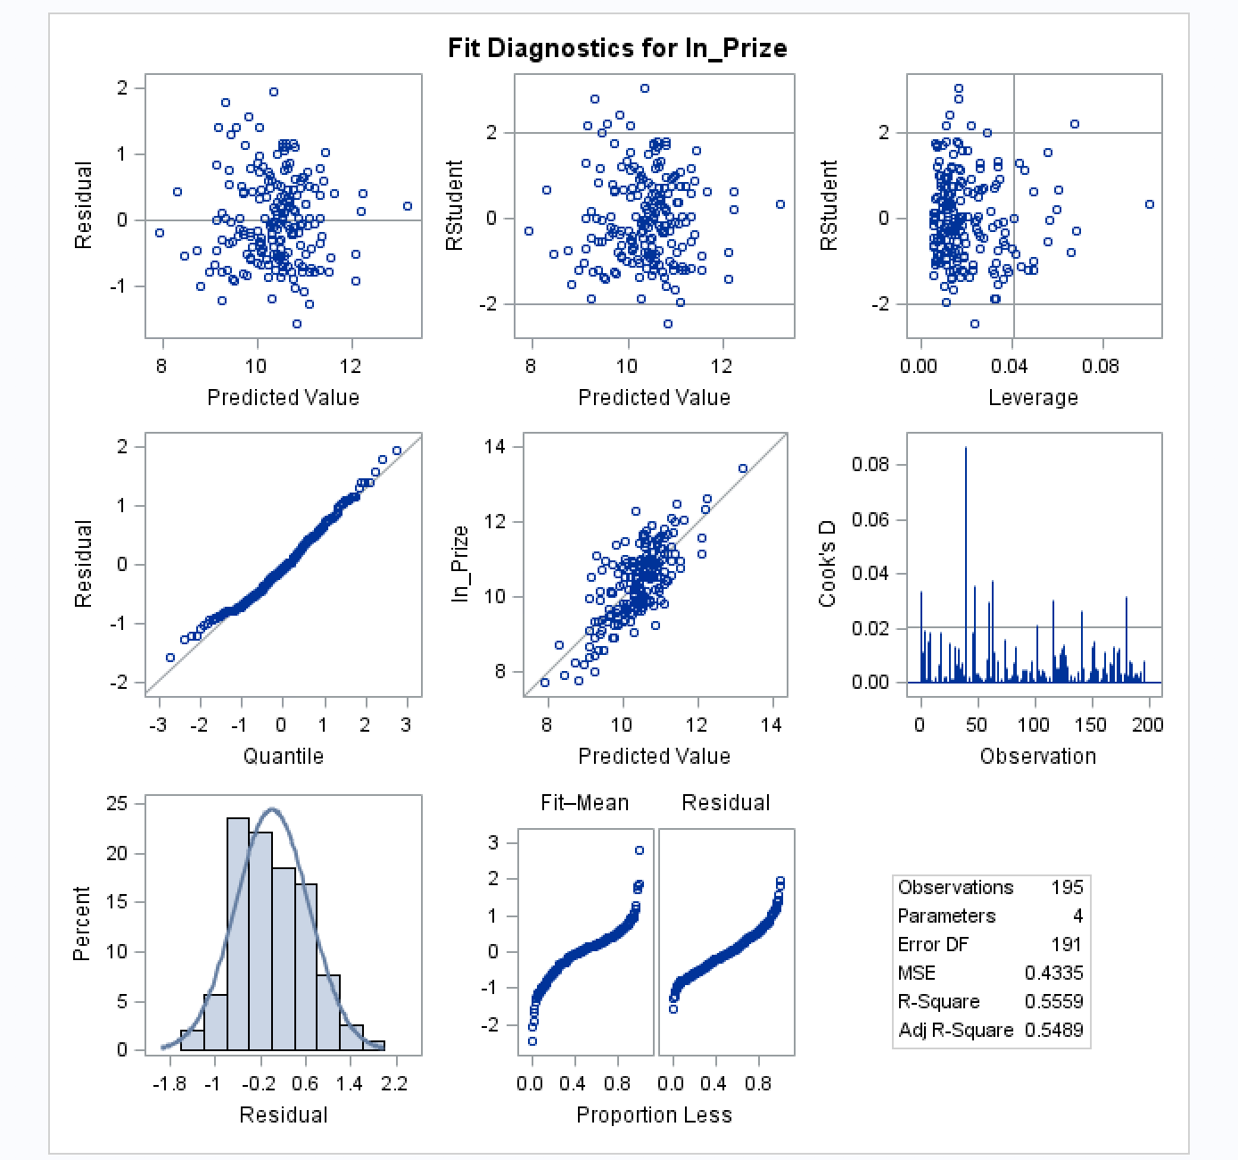

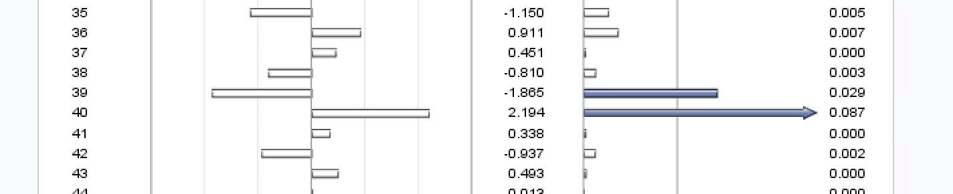

*After removing the one influential point, I can see that our normal probability plot is beginning to look less curved. I can still see some curve to it. I’m noticing that R2 and Adj R2 is still not very high so I would like to continue to investigate influential points. There is still one influential point that I will investigate to see if its removal will improve our model. This is point 40.*

*\*dropping outliers and influential points;*

*TITLE 'mydwith outlier and influential point removed';*

*data myd_new1;*

*set myd_new;*

*if _n_=40 then delete;*

*run;*

*\*regression model on myd - outliers and influential points;*

*TITLE 'Regression Analysis with outliers and influential points removed';*

*PROC REG data=myd_new1;*

*MODEL ln_Prize=GIR BirdieConversion PuttsPerRound / influence r;*

*\*residual plots;*

*PLOT student.*predicted.;*

*PLOT student.*(GIR BirdieConversion PuttsPerRound);*

*PLOT npp.*student.;*

*run;*

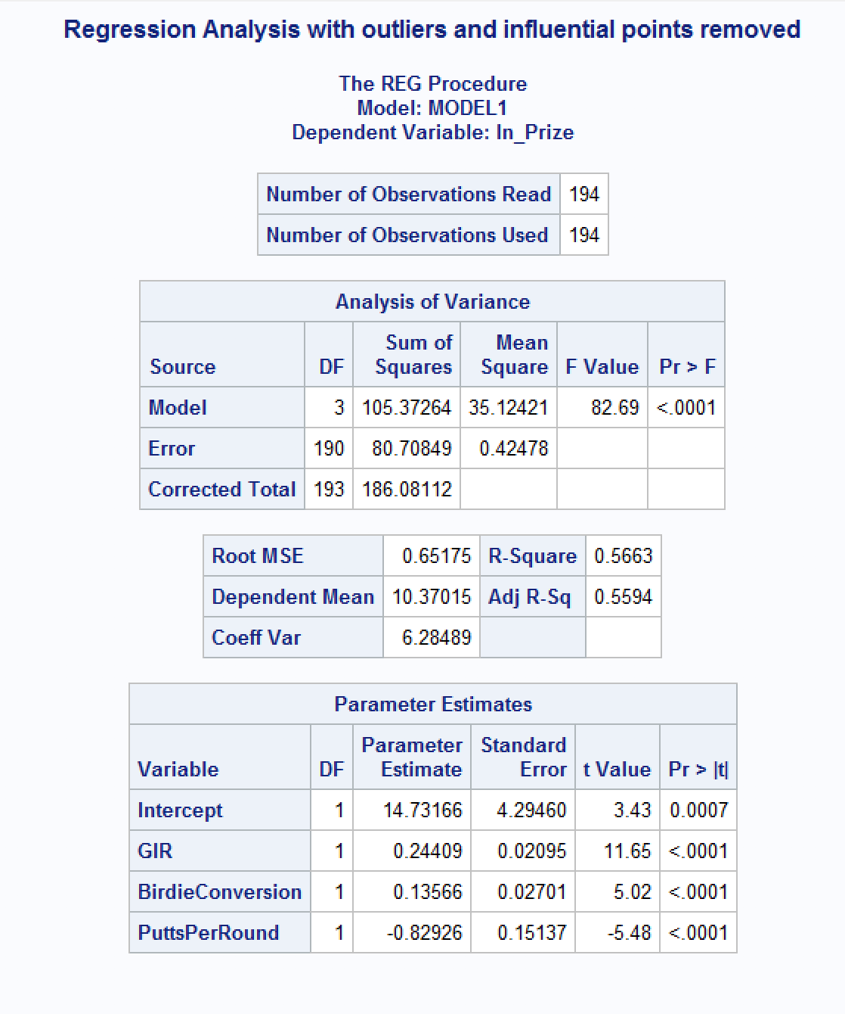

*I’m noticing that R2 and Adj R2 are still pretty low. Our model only accounts for approximately 56% of the variation of PrizeMoney. I continued to spend time removing more influential points (I decided not to repeat all the code here) and I was able to get the R2 and Adj R2 up to approximately 69%. I’m actually not sure if this is valid to continue to remove influential points as I see the R2 and Adj R2. I chose to continue removing the influential points in blue as I continued to see improvement in the normal probability line and the above values. After approximately 19 removals, the statistics stopped improving. I will add the output from my final influential points removal.*

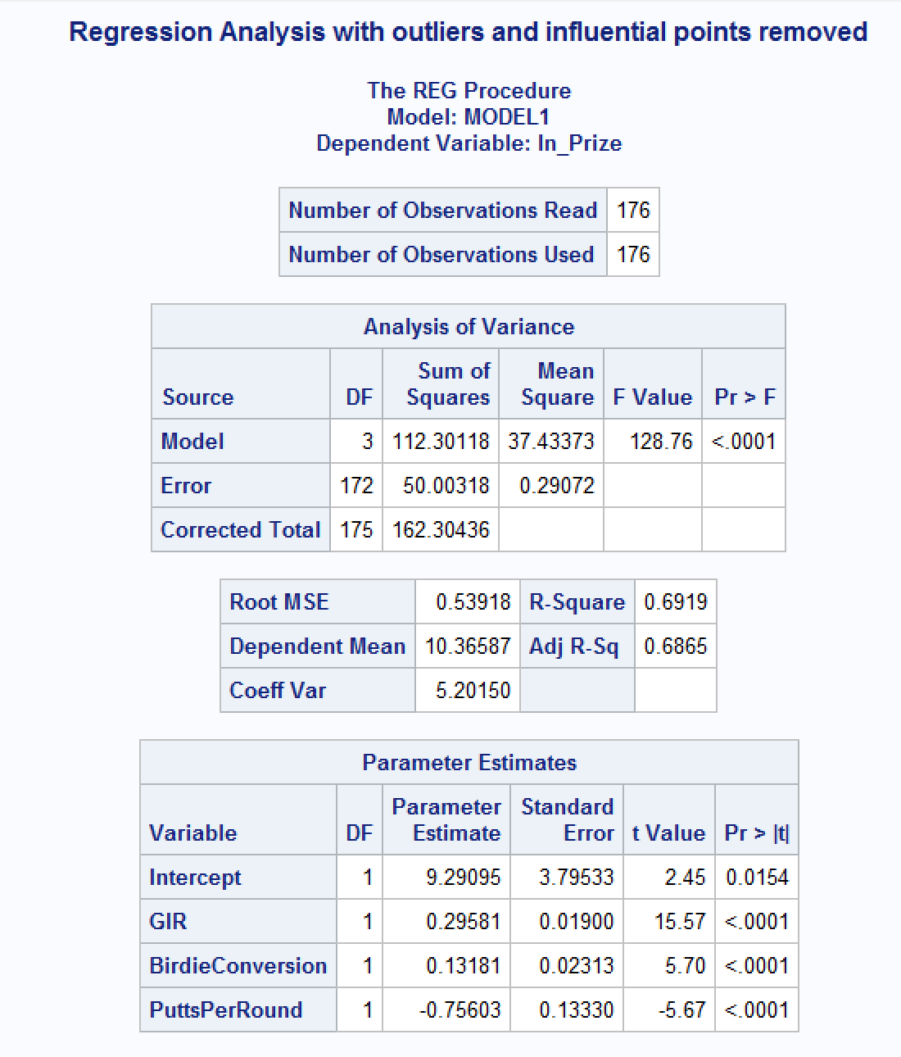

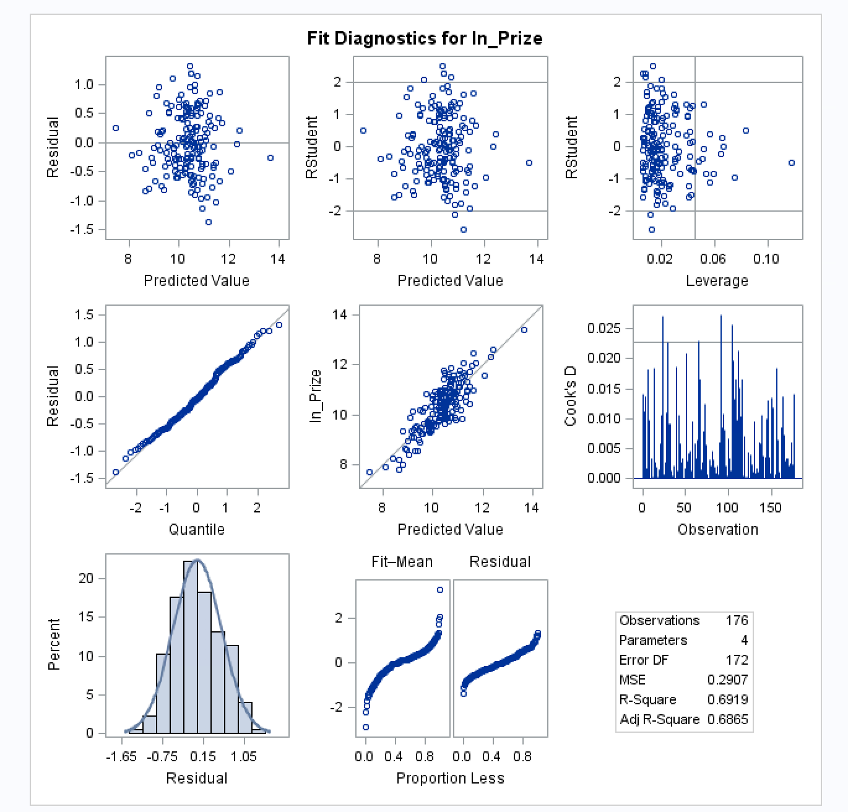

* + Write down the final model equation. Discuss why this is the best model. Include all relevant statistics/values to substantiate your answer.

***Answer:***

*The final fitted model equation is:*

*Log(Prize_Money) = 9.29095 + 0.29581(GIR) + 0.13181(BirdieConversion) – 0.75603(PutsPerRound) + e*

*I can see that F-Value is high and RMSE is low with this final model which along with the higher R2 and Adj R2 show improvement in the model. The normal probability model appears less curved and with a 45 degree angle which tells me that this final model does not violate normality. My concern is still if it is good practice to remove influential points while we see are continuing to see improvement.*

1. Interpret the regression coefficients in the final model to answer the following question: How does an increase in 1% for GIR affect the average Prize money?

***Answer:***

*Using the formula from our notes I know that:*

*(exp(0.29581) – 1) = 0.3442147318 * 100 = 34.42147318 or approximately 34%*

*So 1% increase in GIR increases the average Prize money by 34%.*

1. Copy and paste your FULL SAS code into the word document along with your answers.

*Answer: See code and output above*